Lenin on Banking and Monopoly
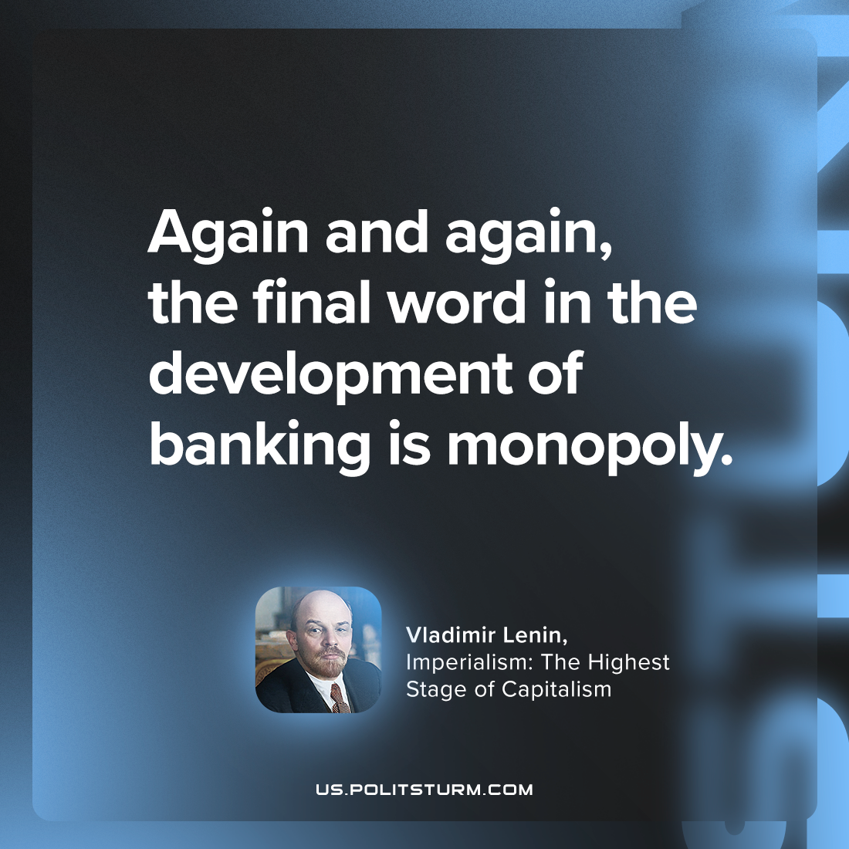

Original article
2023-08-19

"Again and again, the final word in the development of banking is monopoly."
Vladimir Lenin, Imperialism: the Highest Stage of Capitalism

Original article

