Lenin on Agreements of the Ruling Classes
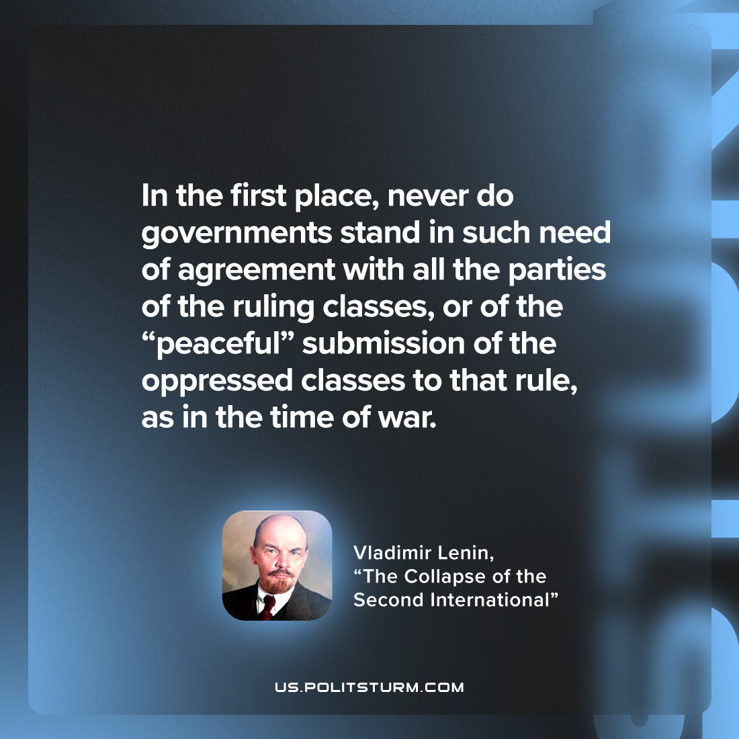

Original article
2022-12-06

"In the first place, never do governments stand in such need of agreement with all the parties of the ruling classes, or of the “peaceful” submission of the oppressed classes to that rule, as in the time of war."
Vladimir Lenin, "The Collapse of the Second International"

Original article

