Lenin on Acts of Terror and Tactics
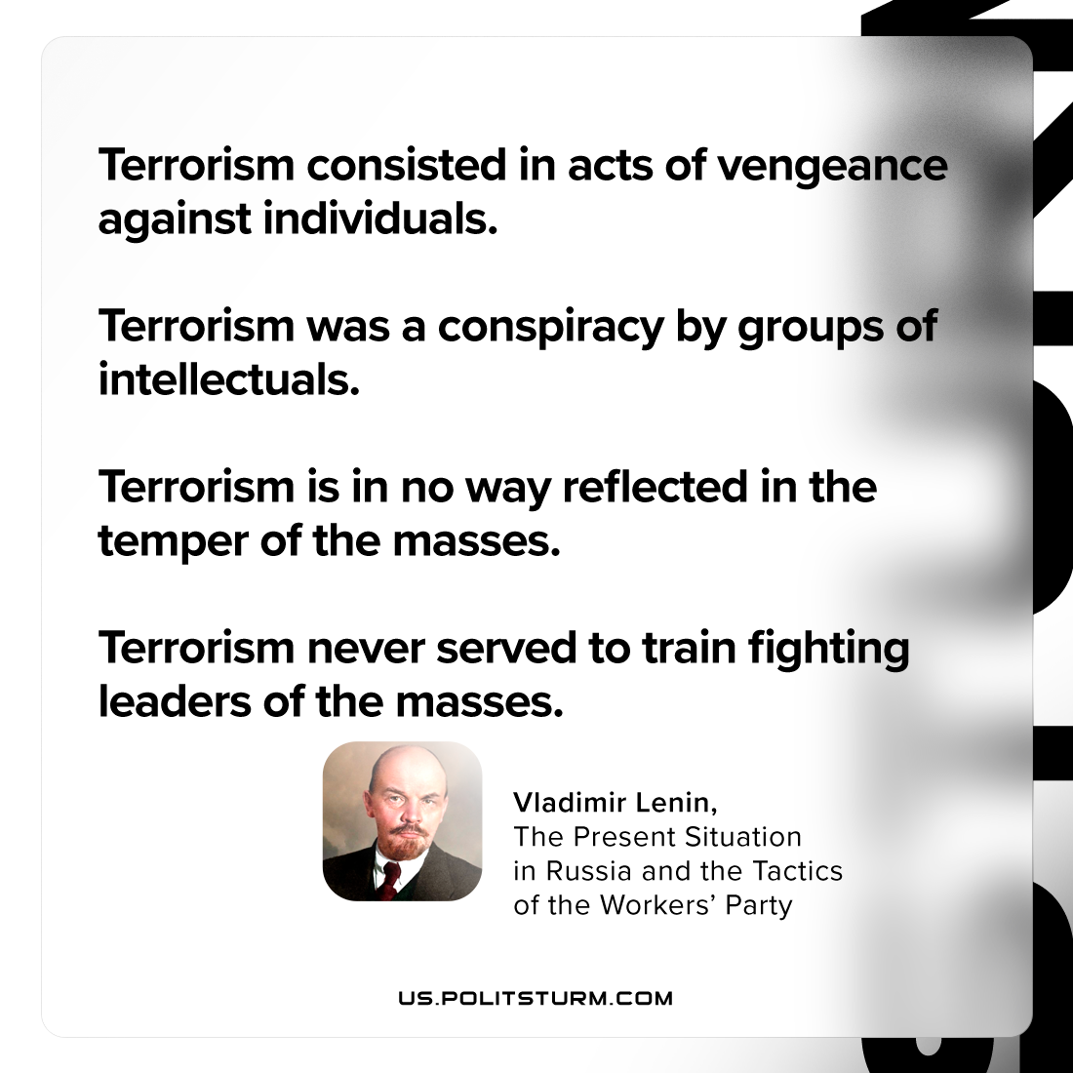

Original article
2023-04-22

"Terrorism consisted in acts of vengeance against individuals. Terrorism was a conspiracy by groups of intellectuals. Terrorism in no way reflected in the temper of the masses. Terrorism never served to train fighting leaders of the masses."
Vladimir Lenin, “The Present Situation in Russia and the Tactics of the Workers’ Party”

Original article

