Lenin on the use of National Liberation to Deceive the Workers
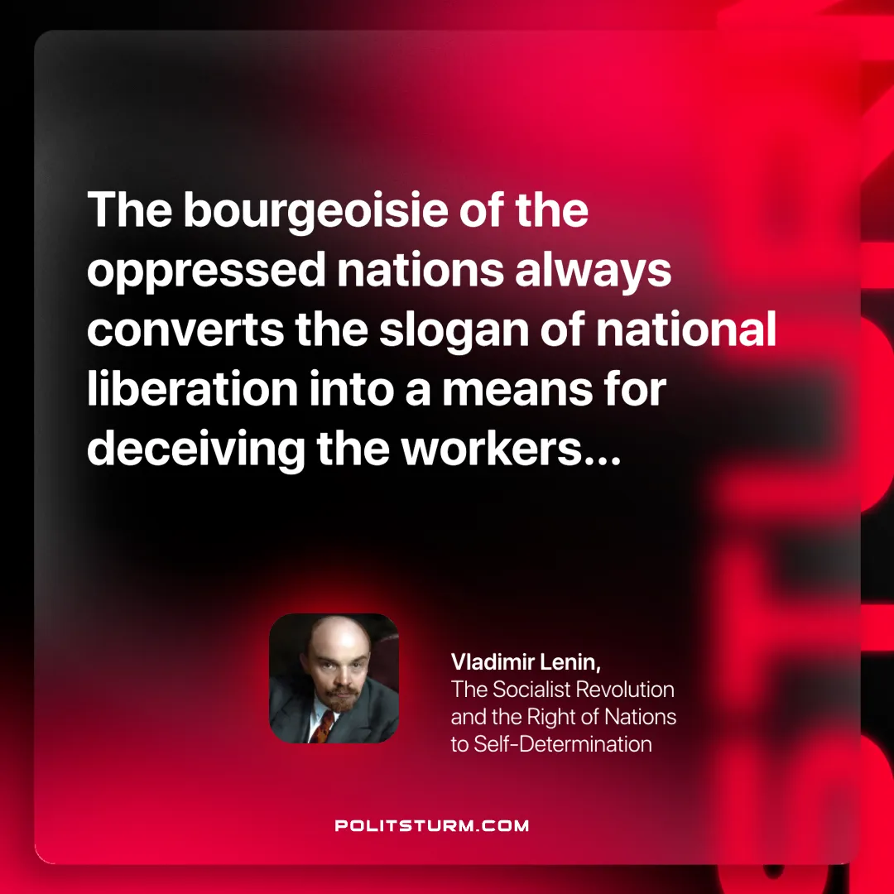

Original article
2024-10-03

“The bourgeoisie of the oppressed nations always converts the slogan of national liberation into a means for deceiving the workers…”
V.I. Lenin, The Socialist Revolution and the Right of Nations to Self-Determination.

Original article

