Lenin on the Fraud of National Culture
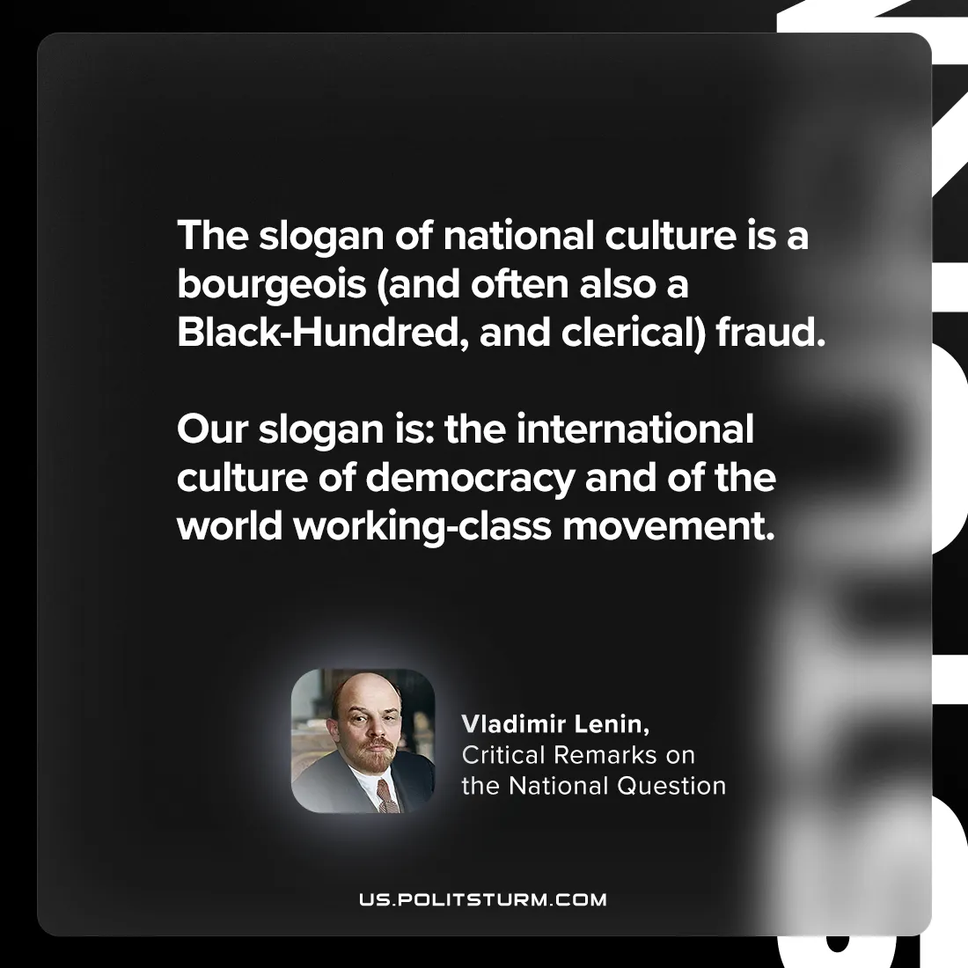

Original article
2024-09-14

“The slogan of national culture is a bourgeois (and often also a Black-Hundred, and clerical) fraud. Our slogan is: the international culture of democracy and of the world working-class movement.”
Vladimir Lenin, Critical Remarks on the National Question

Original article

