Lenin on the "Defence of the Fatherland"
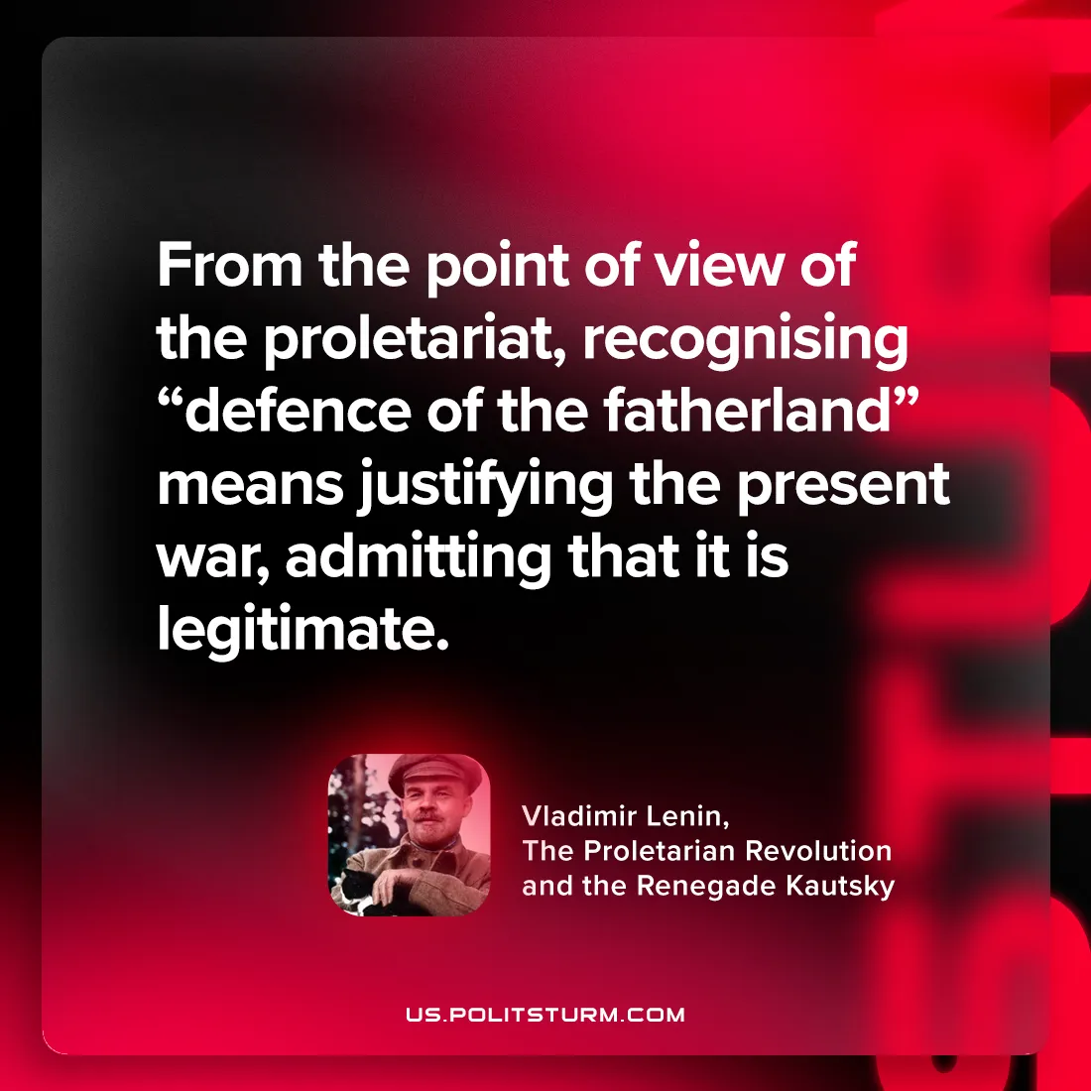

Original article
2024-07-27

"From the point of view of the proletariat, recognising “defence of the fatherland” means justifying the present war, admitting that it is legitimate.”
Vladimir Lenin, The Proletarian Revolution and the Renegade Kautsky

Original article

