Lenin on the Choice Between Capitalist Oppression or Socialist Liberation
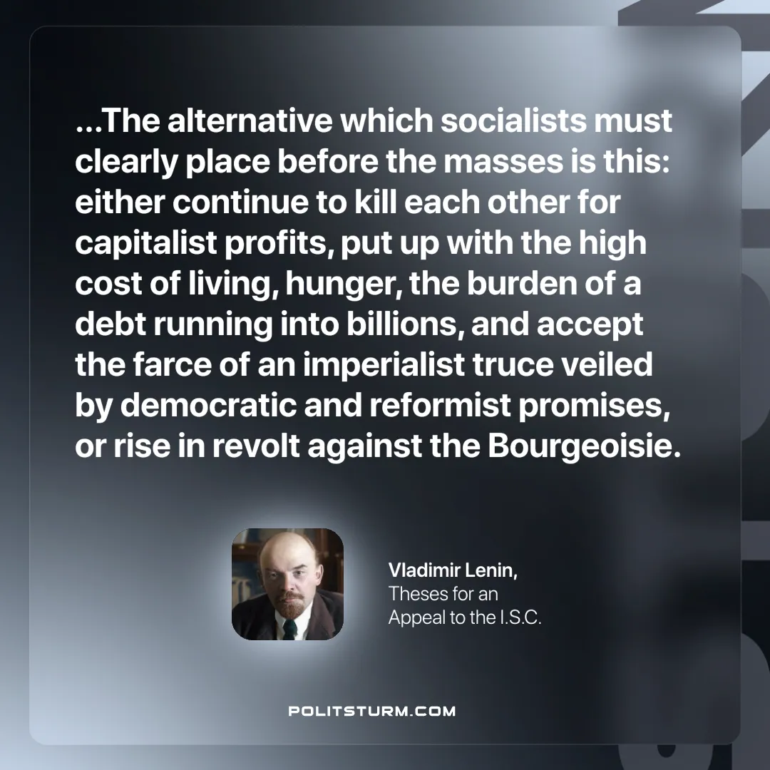

Original article
2025-06-22

“...The alternative which socialists must clearly place before the masses is this: either continue to kill each other for capitalist profits, put up with the high cost of living, hunger, the burden of a debt running into billions, and accept the farce of an imperialist truce veiled by democratic and reformist promises, or rise in revolt against the Bourgeoisie.”
Vladimir Lenin, Theses for an Appeal to the I.S.C

Original article

