Lenin on Only a Worker Government Providing Basic Needs
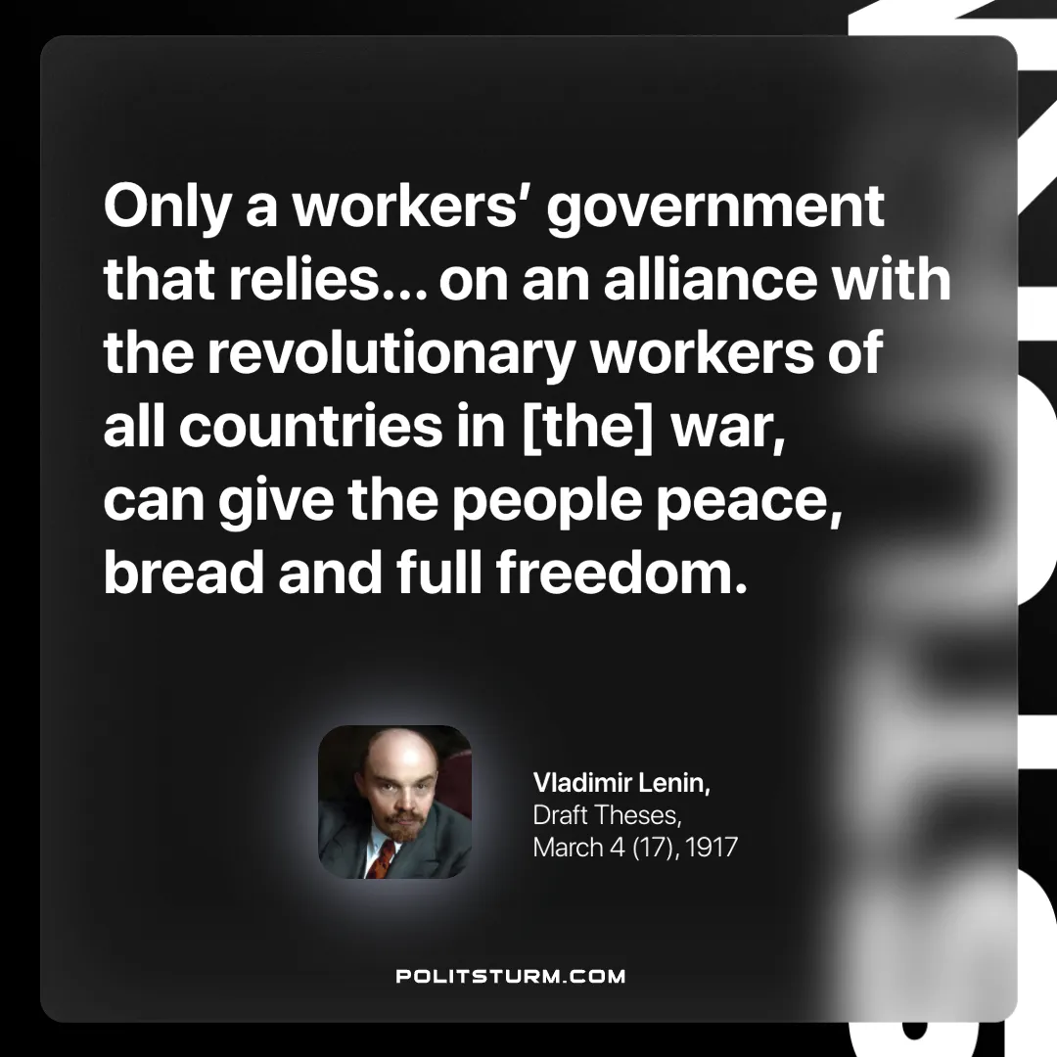

Original article
2025-06-19

“Only a workers’ government that relies… on an alliance with the revolutionary workers of all countries in [the] war, can give the people peace, bread and full freedom.”
Vladimir Lenin, Draft Theses, March 4 (17), 1917

Original article

