Lenin on the Conditions of Imperialism Forcing Struggles
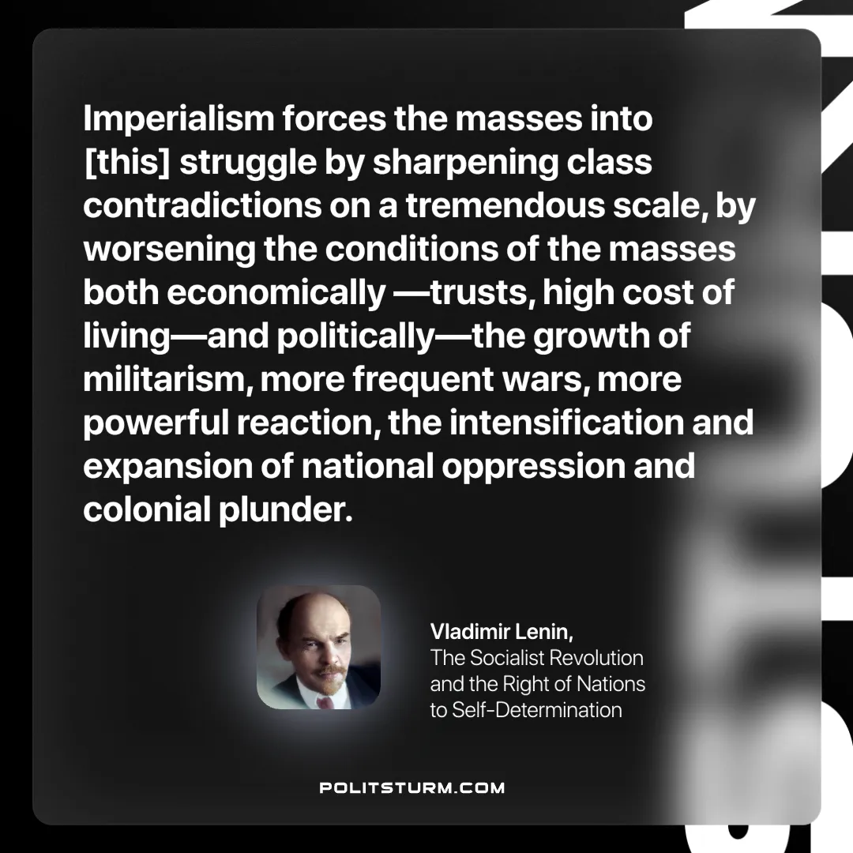

Original article
2025-06-07

“Imperialism forces the masses into [this] struggle by sharpening class contradictions on a tremendous scale, by worsening the conditions of the masses both economically —trusts, high cost of living—and politically—the growth of militarism, more frequent wars, more powerful reaction, the intensification and expansion of national oppression and colonial plunder.”
Vladimir Lenin, The Socialist Revolution and the Right of Nations to Self-Determination

Original article

