Lenin on the Need to Purge Opportunists
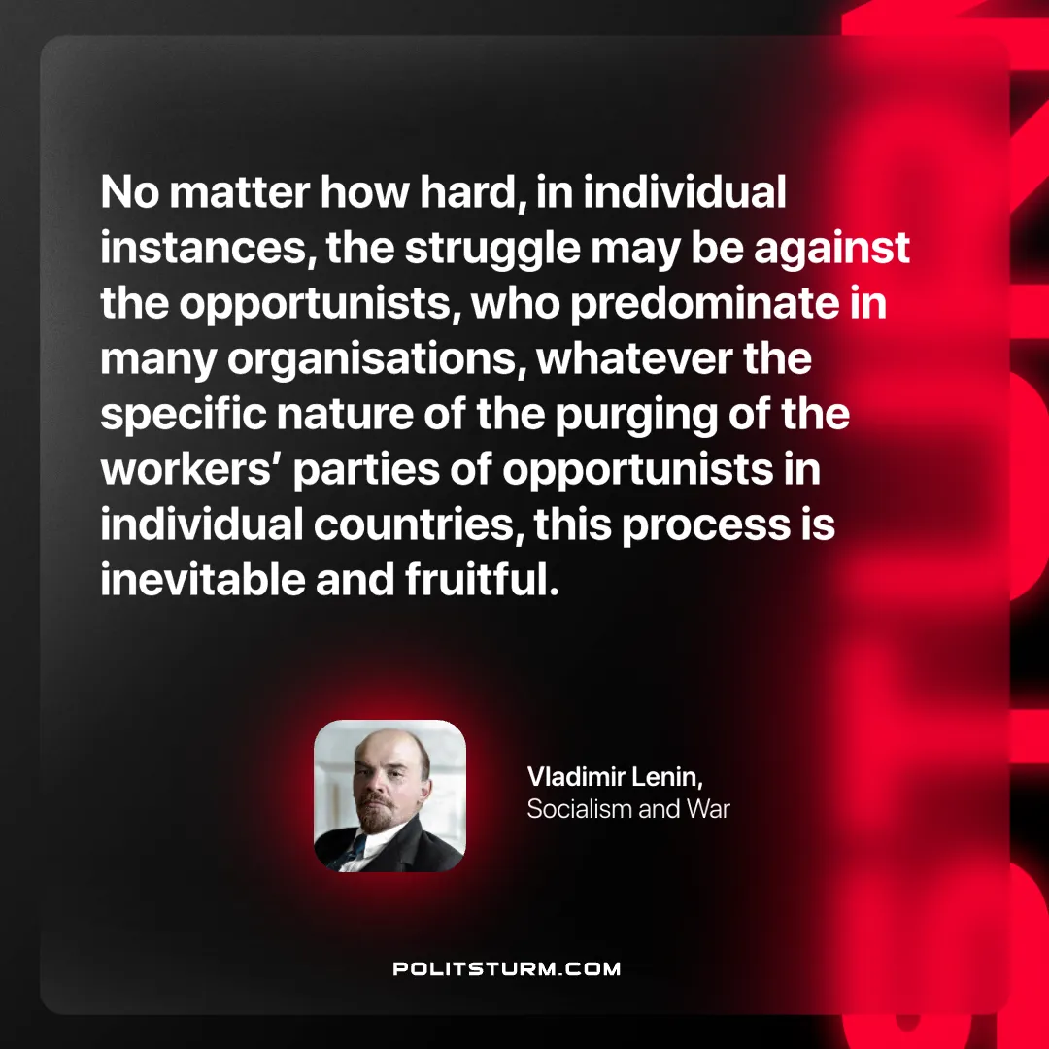

Original article
2025-04-20

"No matter how hard, in individual instances, the struggle may be against the opportunists, who predominate in many organisations, whatever the specific nature of the purging of the workers’ parties of opportunists in individual countries, this process is inevitable and fruitful."
Vladimir Lenin, Socialism and War

Original article

