Lenin on How the Capitalist Tricks the Workers to Support Their Wars
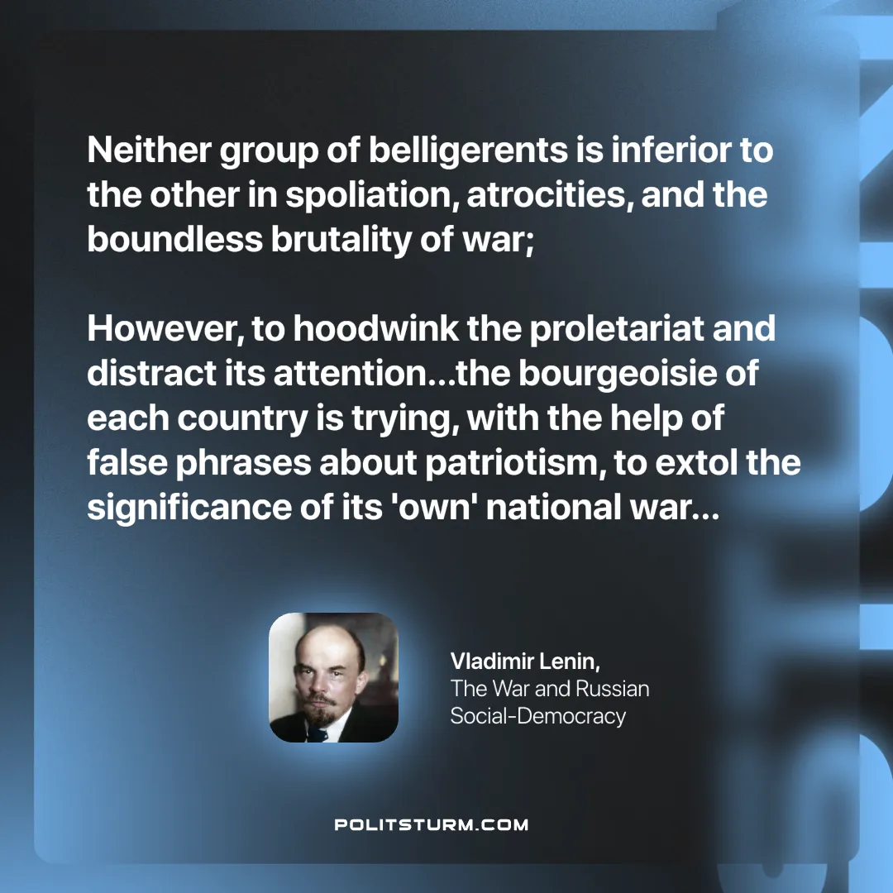

Original article
2025-04-10

"Neither group of belligerents is inferior to the other in spoliation, atrocities, and the boundless brutality of war; however, to hoodwink the proletariat and distract its attention…the bourgeoisie of each country is trying, with the help of false phrases about patriotism, to extol the significance of its 'own' national war…"
Vladimir Lenin, The War and Russian Social-Democracy

Original article

