Lenin on How Nationalism Divides the Workers
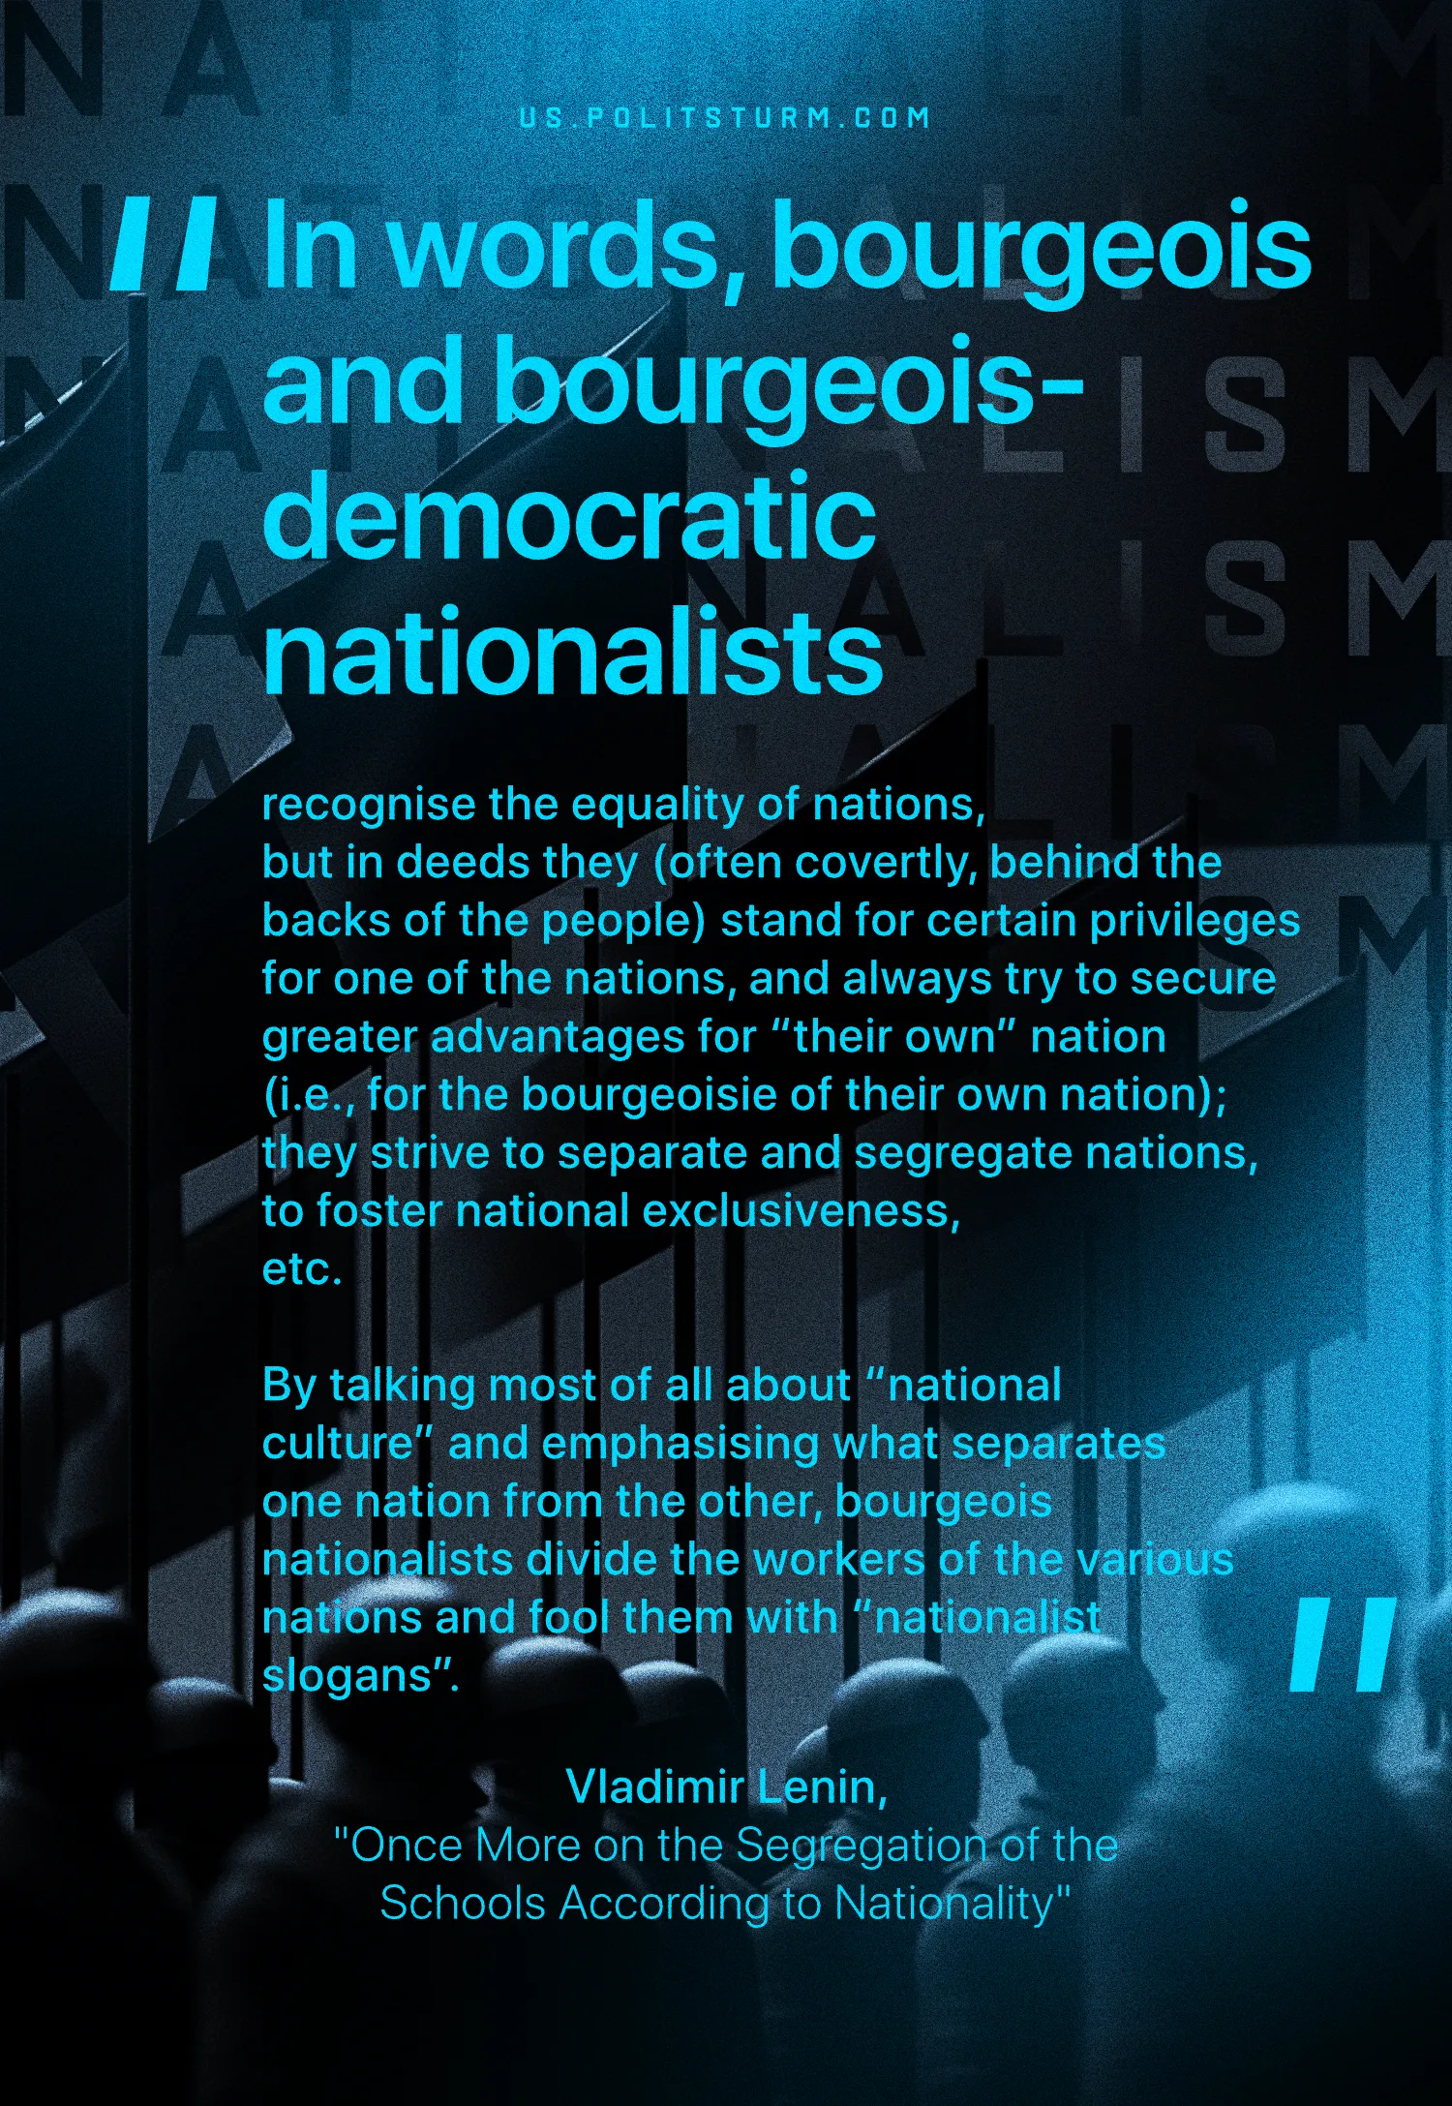

Original article
2025-02-02
1 min read

“In words, bourgeois and bourgeois-democratic nationalists recognise the equality of nations, but in deeds they (often covertly, behind the backs of the people) stand for certain privileges for one of the nations, and always try to secure greater advantages for “their own” nation (i.e., for the bourgeoisie of their own nation); they strive to separate and segregate nations, to foster national exclusiveness, etc.
By talking most of all about “national culture” and emphasising what separates one nation from the other, bourgeois nationalists divide the workers of the various nations and fool them with “nationalist slogans”.”
Vladimir Lenin, Once More on the Segregation of the Schools According to Nationality

Original article

