Lenin on Imperialist "Salvation" and the Division of the World
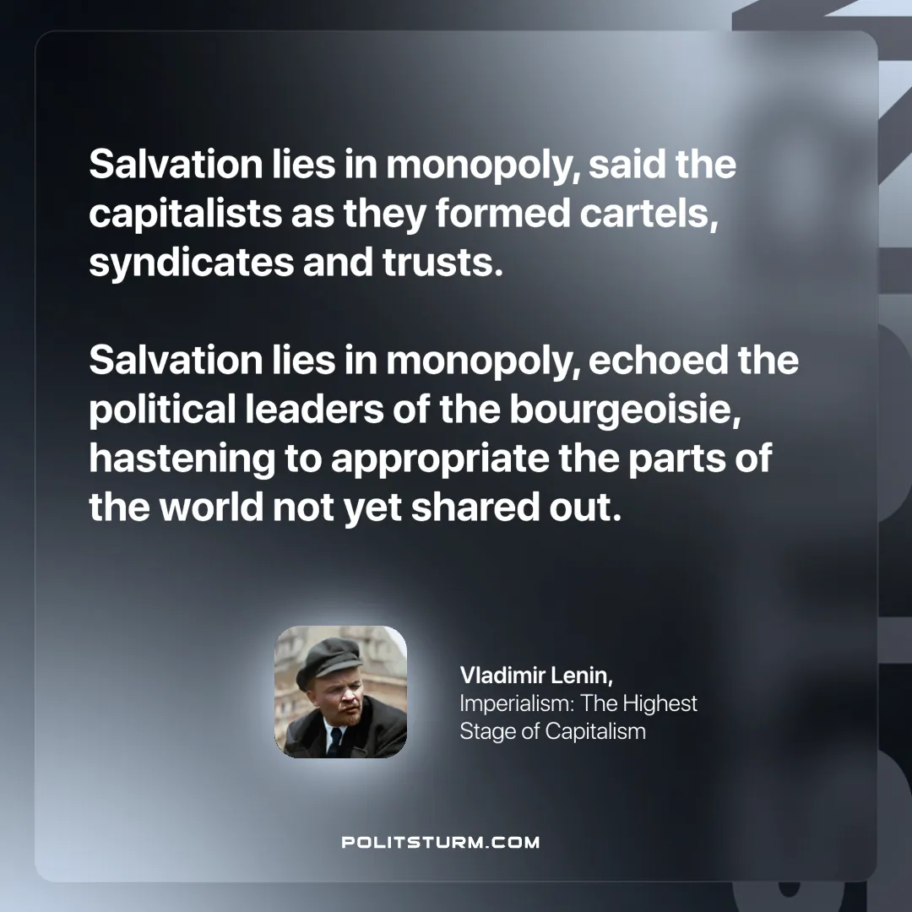

Original article
2024-11-30

“Salvation lies in monopoly, said the capitalists as they formed cartels, syndicates and trusts. Salvation lies in monopoly, echoed the political leaders of the bourgeoisie, hastening to appropriate the parts of the world not yet shared out.”
Vladimir Lenin, Imperialism: The Highest Stage of Capitalism

Original article

