Lenin on the Repressive Essence of Capitalist Democracy
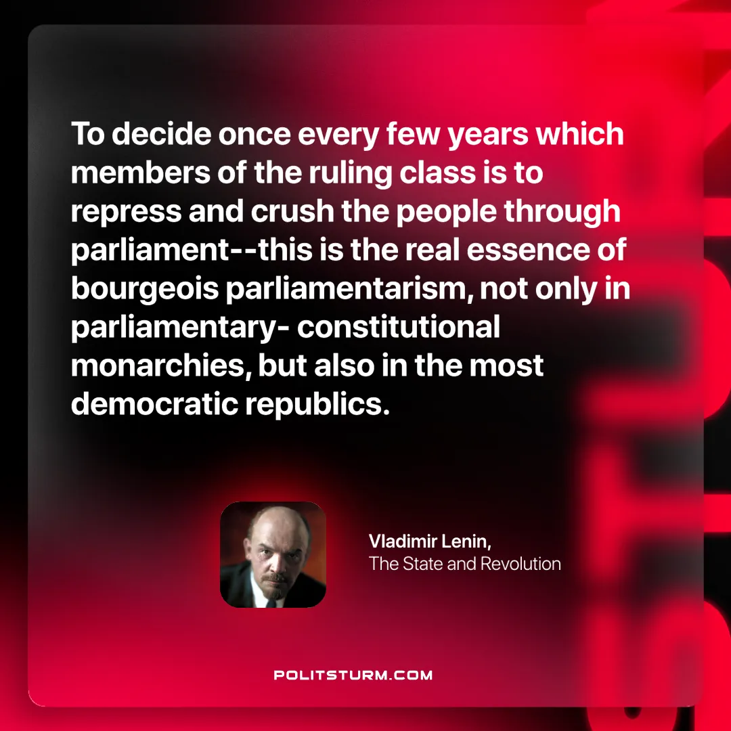

Original article
2024-11-21

“To decide once every few years which members of the ruling class is to repress and crush the people through parliament--this is the real essence of bourgeois parliamentarism, not only in parliamentary- constitutional monarchies, but also in the most democratic republics.”
Vladimir Lenin, The State and Revolution

Original article

