Lenin on the Sweeping Away of Feudal Society
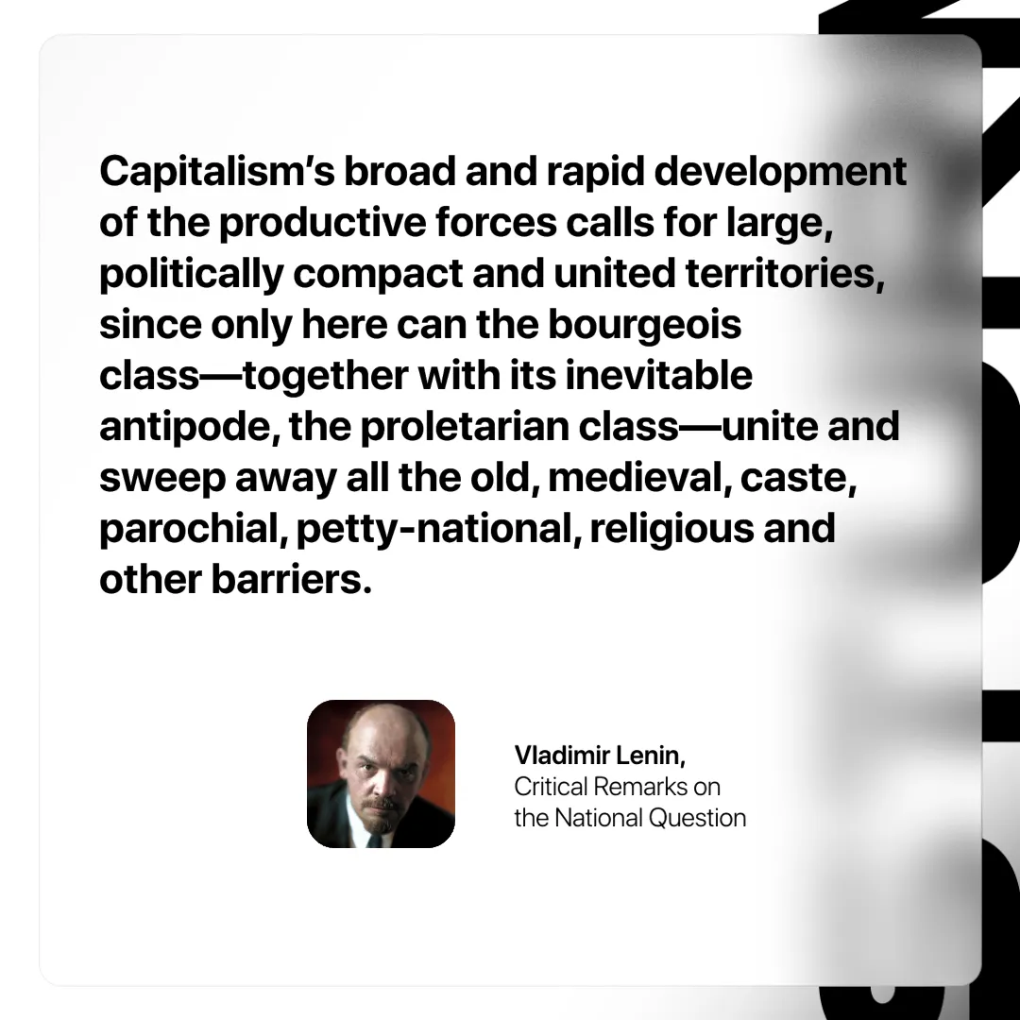

Original article
2024-11-12

“Capitalism’s broad and rapid development of the productive forces calls for large, politically compact and united territories, since only here can the bourgeois class—together with its inevitable antipode, the proletarian class—unite and sweep away all the old, medieval, caste, parochial, petty-national, religious and other barriers.”
Vladimir Lenin, Critical Remarks on the National Question

Original article

