Lenin on Bringing the Labor Movement Towards Communism
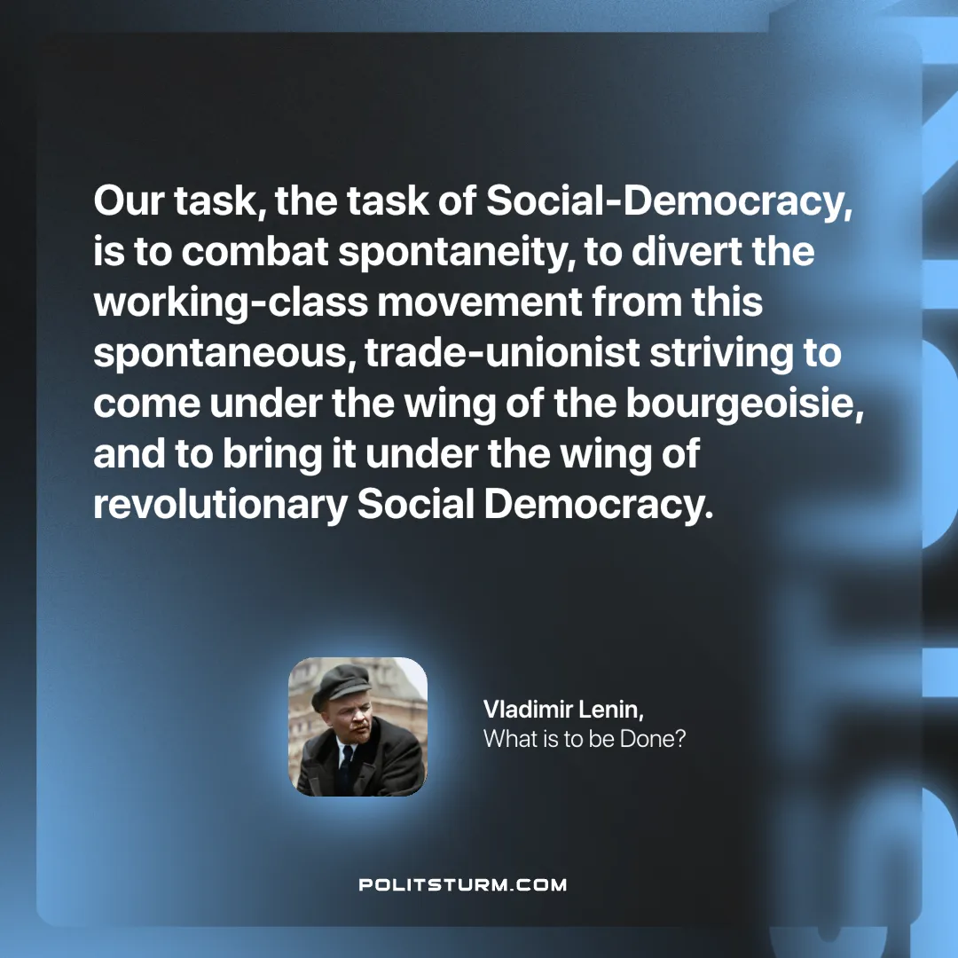

Original article
2024-11-10

“Our task, the task of Social-Democracy, is to combat spontaneity, to divert the working-class movement from this spontaneous, trade-unionist striving to come under the wing of the bourgeoisie, and to bring it under the wing of revolutionary Social Democracy.”
Vladimir Lenin, What is to be Done?

Original article

