Lenin on the Spontaneous Movement Subordinating to the Capitalist
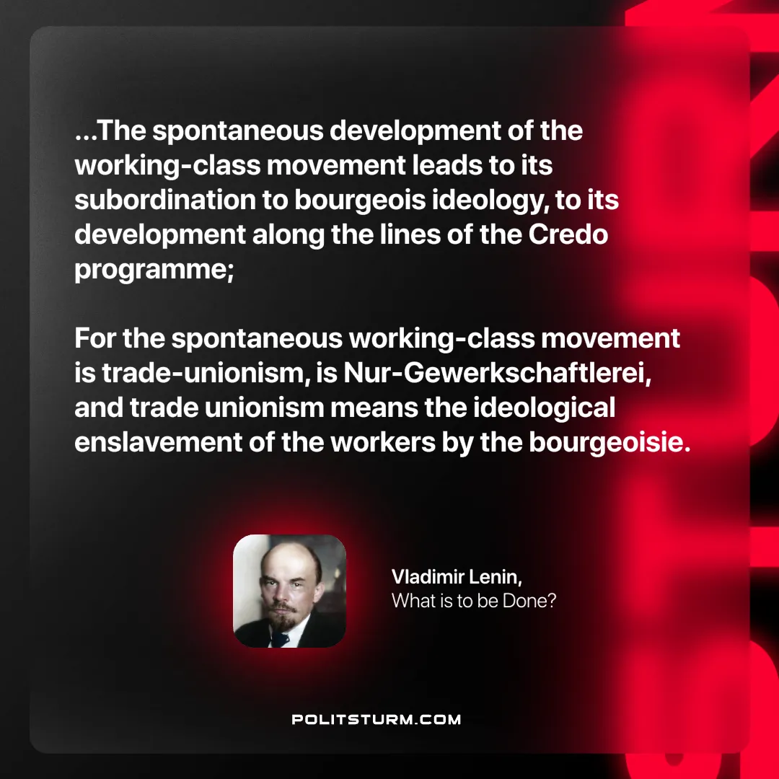

Original article
2024-11-07

“...The spontaneous development of the working-class movement leads to its subordination to bourgeois ideology, to its development along the lines of the Credo programme; for the spontaneous working-class movement is trade-unionism, is Nur-Gewerkschaftlerei, and trade unionism means the ideological enslavement of the workers by the bourgeoisie.”
Vladimir Lenin, What is to be Done?

Original article

