Lenin — 151st Birthday
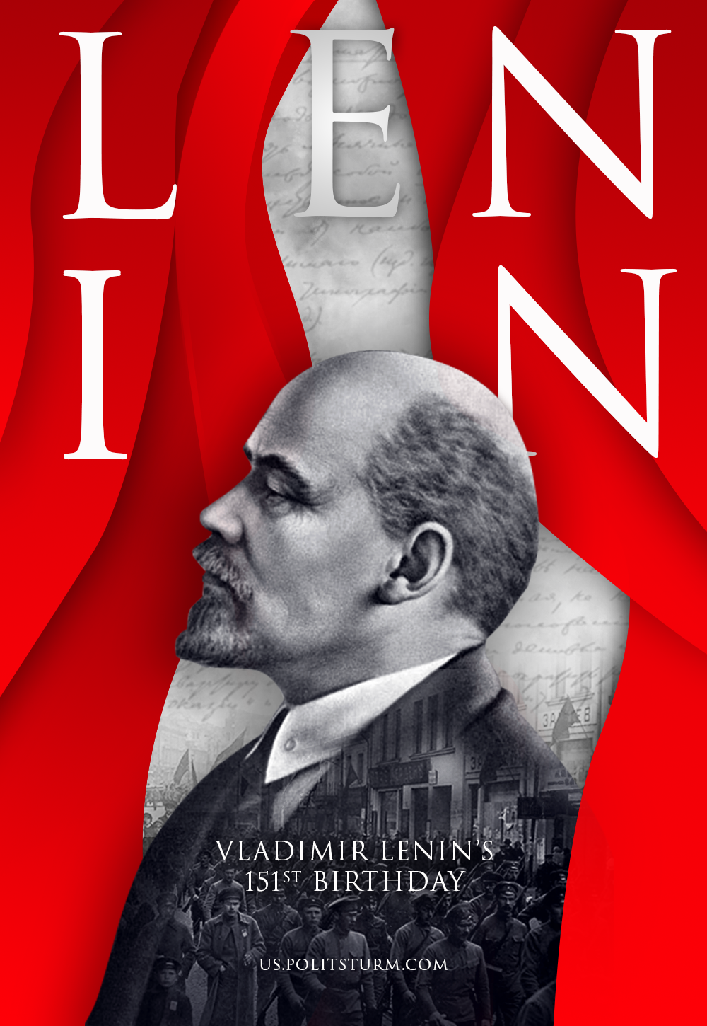

Original article
2021-04-22

On this day, a man was born, whose name has gone down in history forever, as a renewer of human conscience, who devoted his whole life to the liberation of humanity.

Original article

