Lenin on Defeat of One's Own Government in War
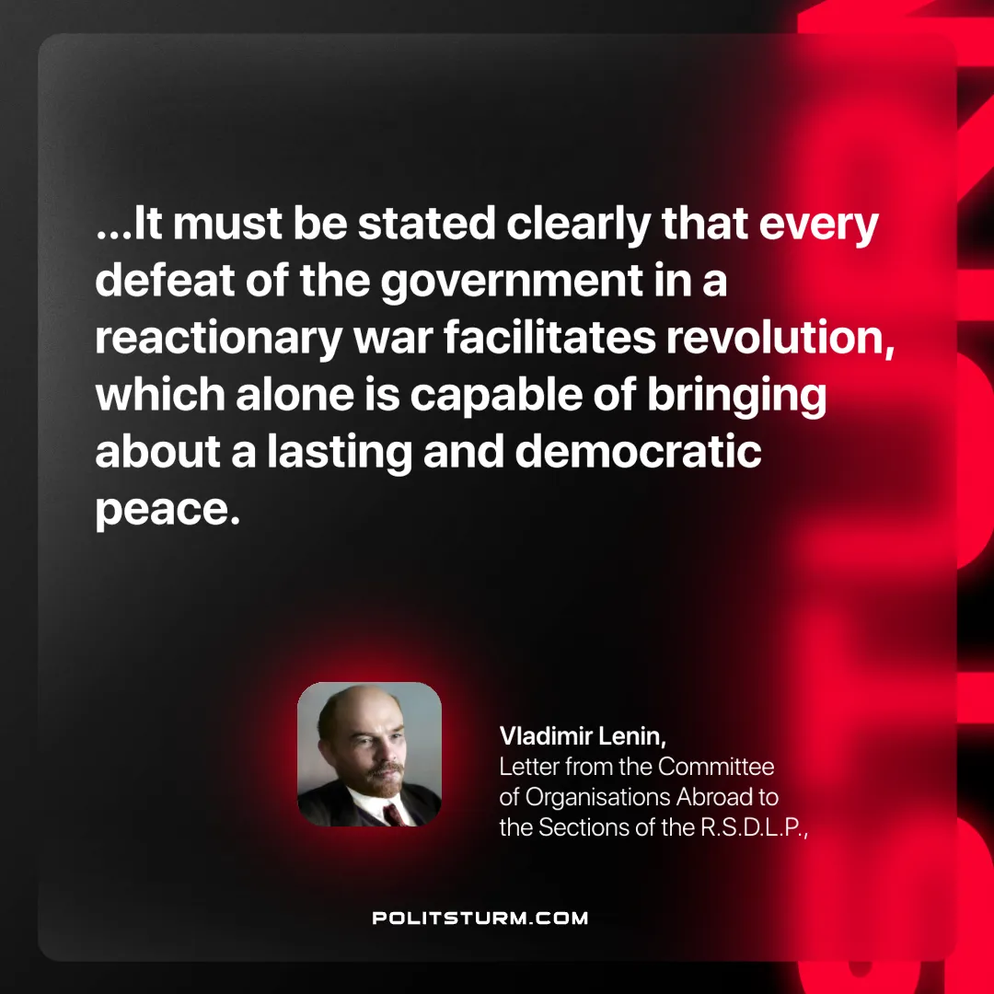

Original article
2025-05-31

“…It must be stated clearly that every defeat of the government in a reactionary war facilitates revolution, which alone is capable of bringing about a lasting and democratic peace.”
Vladimir Lenin, Letter from the Committee of Organisations Abroad to the Sections of the R.S.D.L.P.

Original article

