Lenin on the Role of Opportunism in the Movement
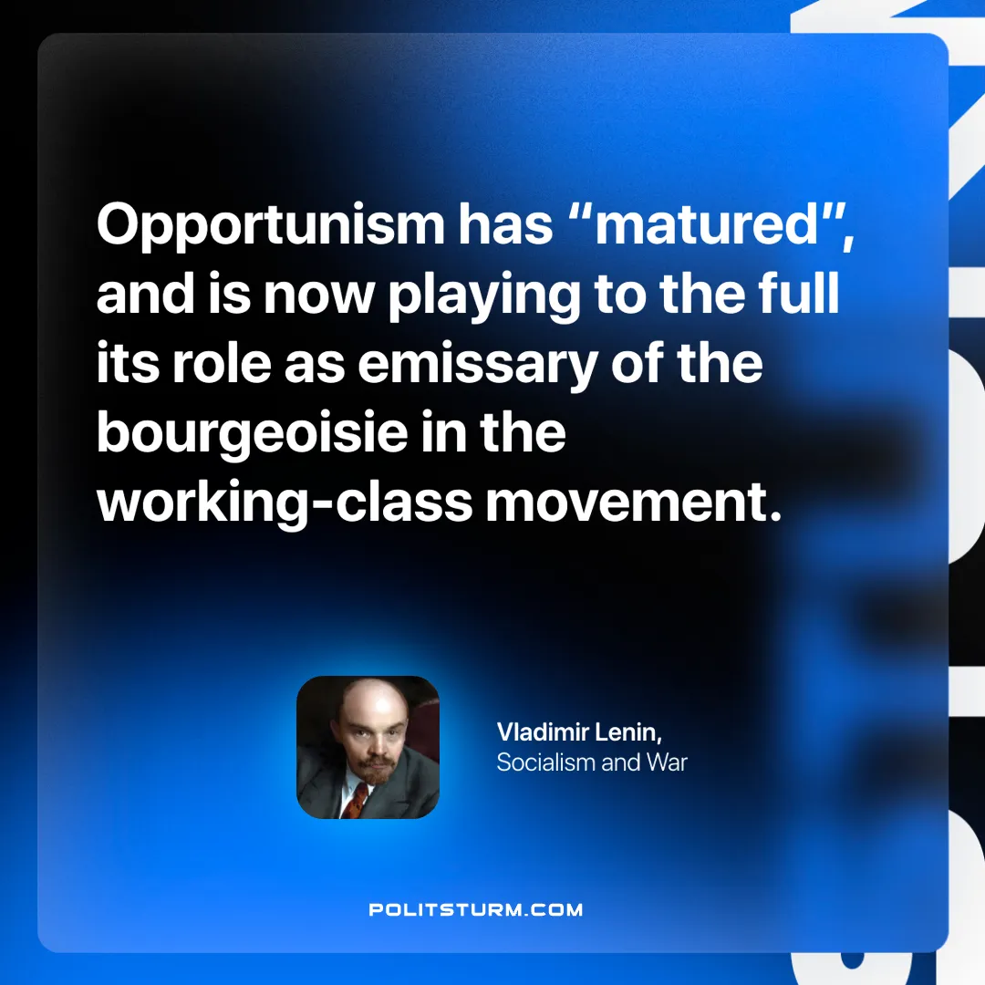

Original article
2025-04-29

“Opportunism has “matured”, and is now playing to the full its role as emissary of the bourgeoisie in the working-class movement.
Vladimir Lenin, Socialism and War

Original article

