Lenin on the Worker's Struggle Against the Capitalist
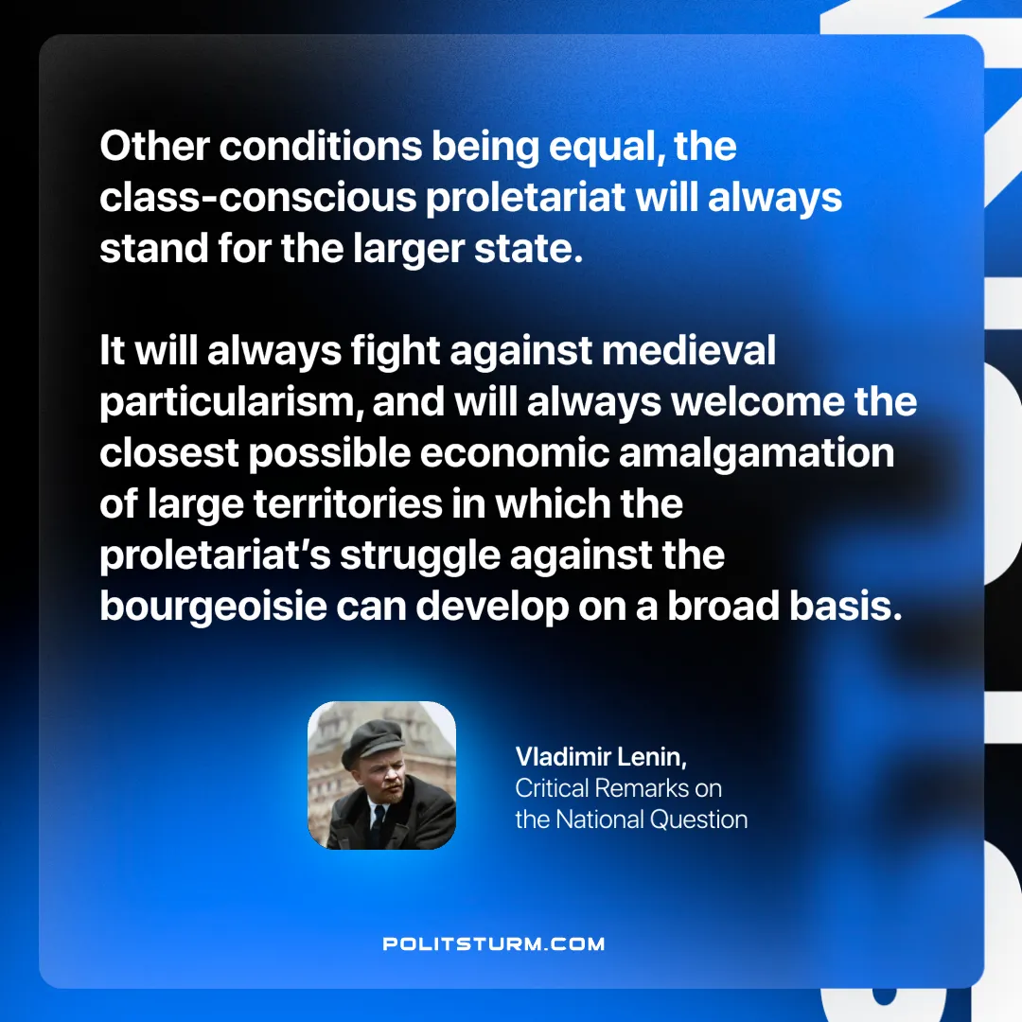

Original article
2024-12-10

“Other conditions being equal, the class-conscious proletariat will always stand for the larger state. It will always fight against medieval particularism, and will always welcome the closest possible economic amalgamation of large territories in which the proletariat’s struggle against the bourgeoisie can develop on a broad basis.”
Vladimir Lenin, Critical Remarks on the National Question

Original article

