Lenin on Giving Privileges to the National Bourgeoisie
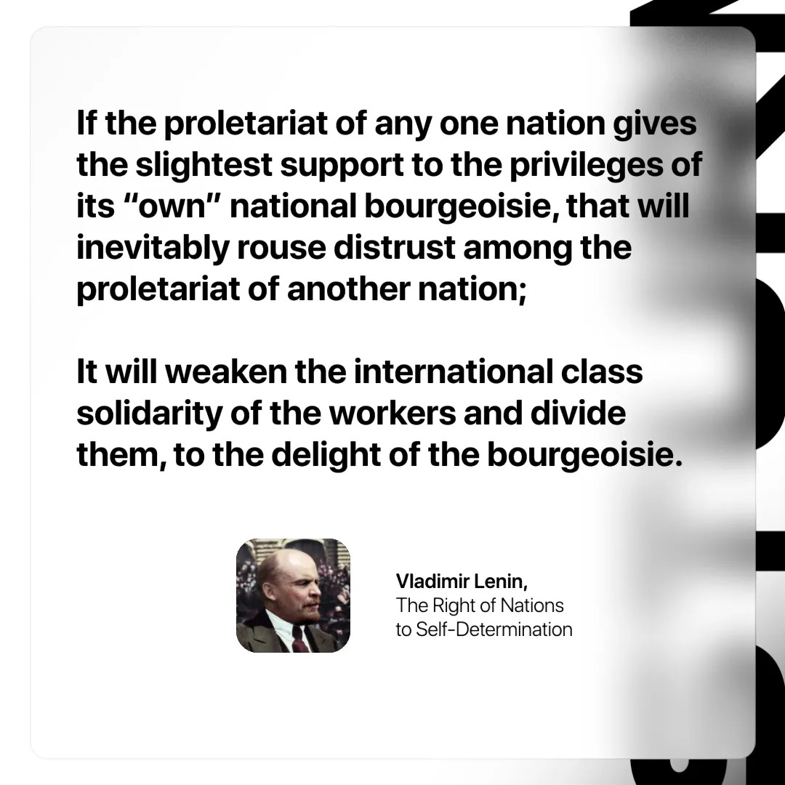

Original article
2024-10-06

“If the proletariat of any one nation gives the slightest support to the privileges of its “own” national bourgeoisie, that will inevitably rouse distrust among the proletariat of another nation; it will weaken the international class solidarity of the workers and divide them, to the delight of the bourgeoisie.”
Vladimir Lenin, The Right of Nations to Self-Determination

Original article

