Lenin on the Drawing Up of the Masses Against Capitalism
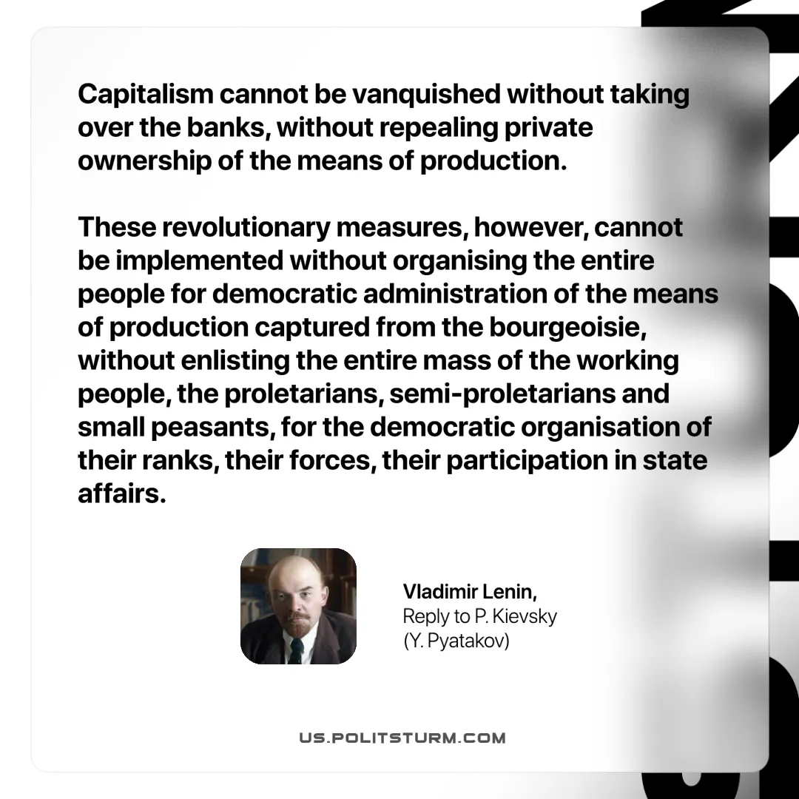

Original article
2025-06-29

“Capitalism cannot be vanquished without taking over the banks, without repealing private ownership of the means of production. These revolutionary measures, however, cannot be implemented without organising the entire people for democratic administration of the means of production captured from the bourgeoisie, without enlisting the entire mass of the working people, the proletarians, semi-proletarians and small peasants, for the democratic organisation of their ranks, their forces, their participation in state affairs.”
Vladimir Lenin, Reply to P. Kievsky (Y. Pyatakov)

Original article

