Lenin on the Consequences of Unity with Social-Chauvinists
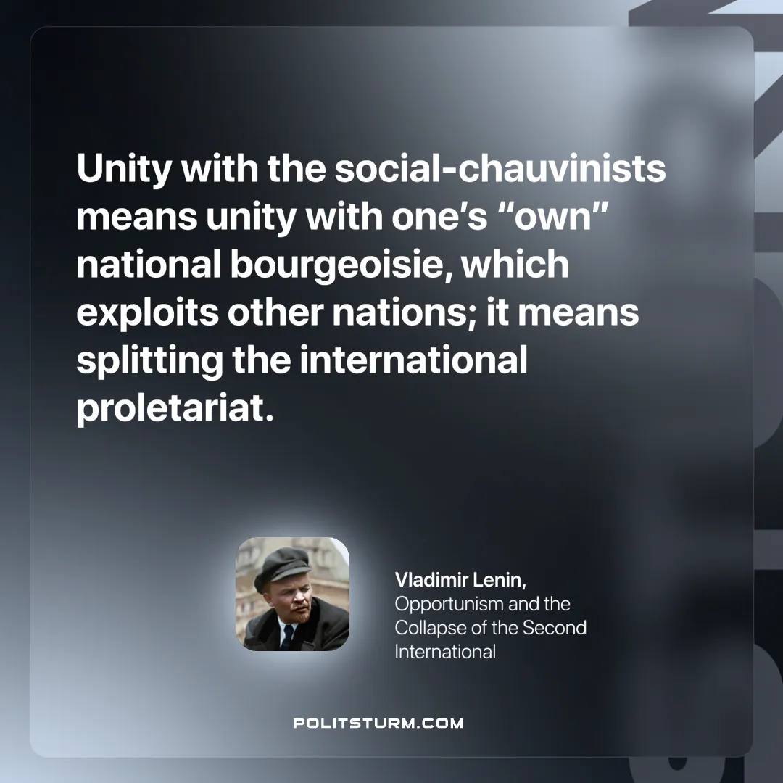

Original article
2025-05-15

“Unity with the social-chauvinists means unity with one’s “own” national bourgeoisie, which exploits other nations; it means splitting the international proletariat.
Vladimir Lenin, Opportunism and the Collapse of the Second International

Original article

