Lenin on the National State Satisfying Capitalism's Requirements
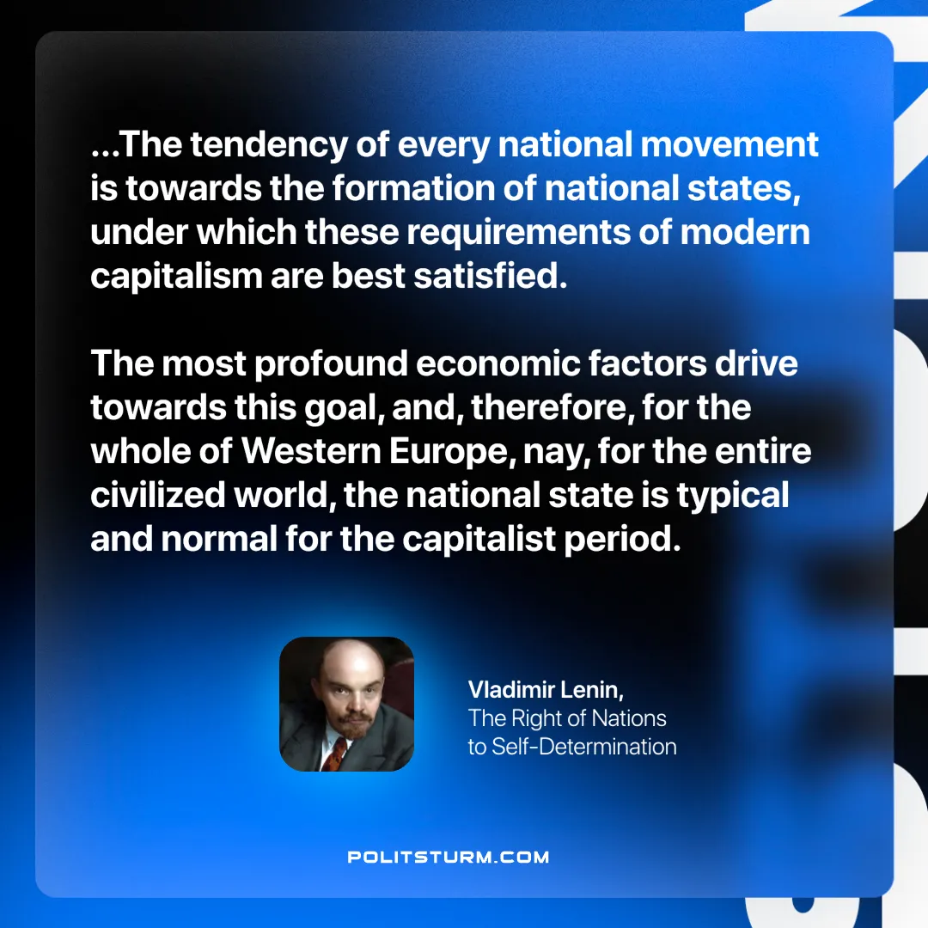

Original article
2025-02-20

“Therefore, the tendency of every national movement is towards the formation of national states, under which these requirements of modern capitalism are best satisfied. The most profound economic factors drive towards this goal, and, therefore, for the whole of Western Europe, nay, for the entire civilized world, the national state is typical and normal for the capitalist period.”
Vladimir Lenin, The Right of Nations to Self-determination

Original article

