Lenin on the Choice Between Capitalist or Socialist Ideology
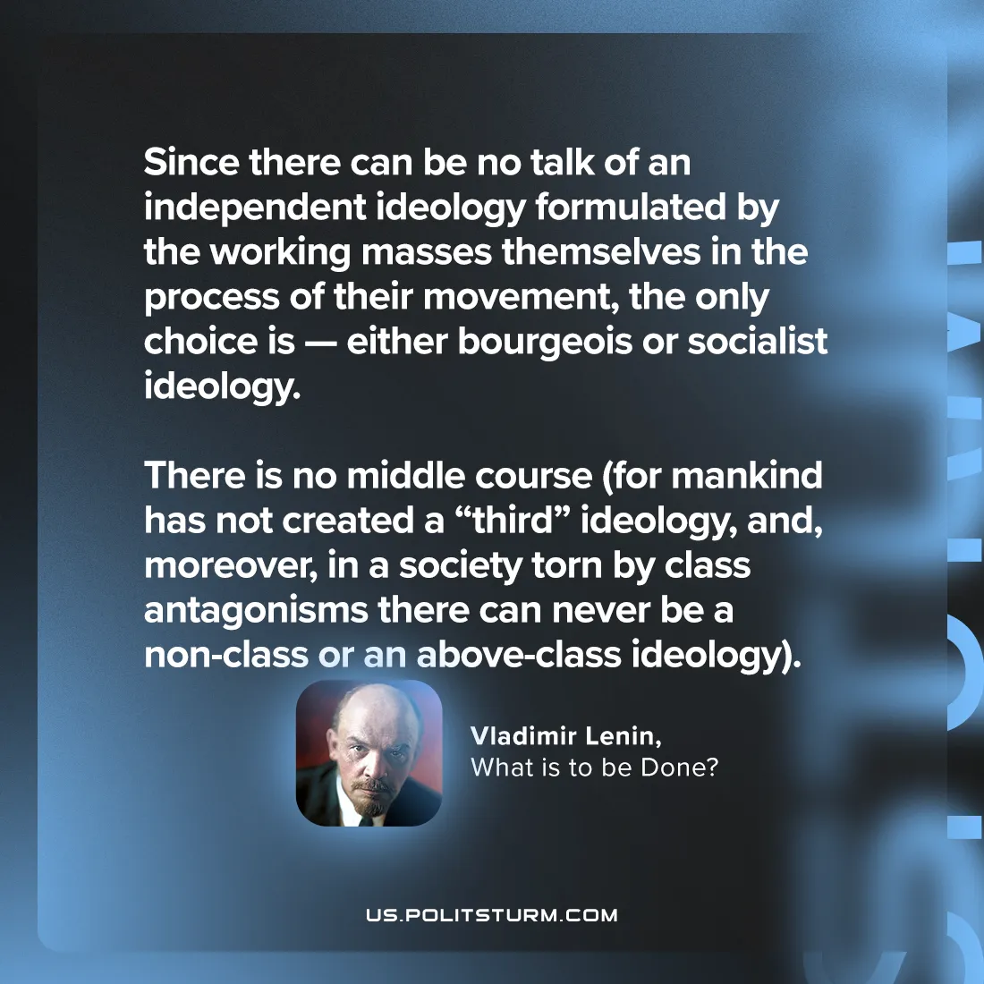

Original article
2024-09-10

"Since there can be no talk of an independent ideology formulated by the working masses themselves in the process of their movement, the only choice is — either bourgeois or socialist ideology. There is no middle course (for mankind has not created a “third” ideology, and, moreover, in a society torn by class antagonisms there can never be a non-class or an above-class ideology)."
Vladimir Lenin, What is to be Done?

Original article

