Large Chinese Companies are Massively Cutting Staff
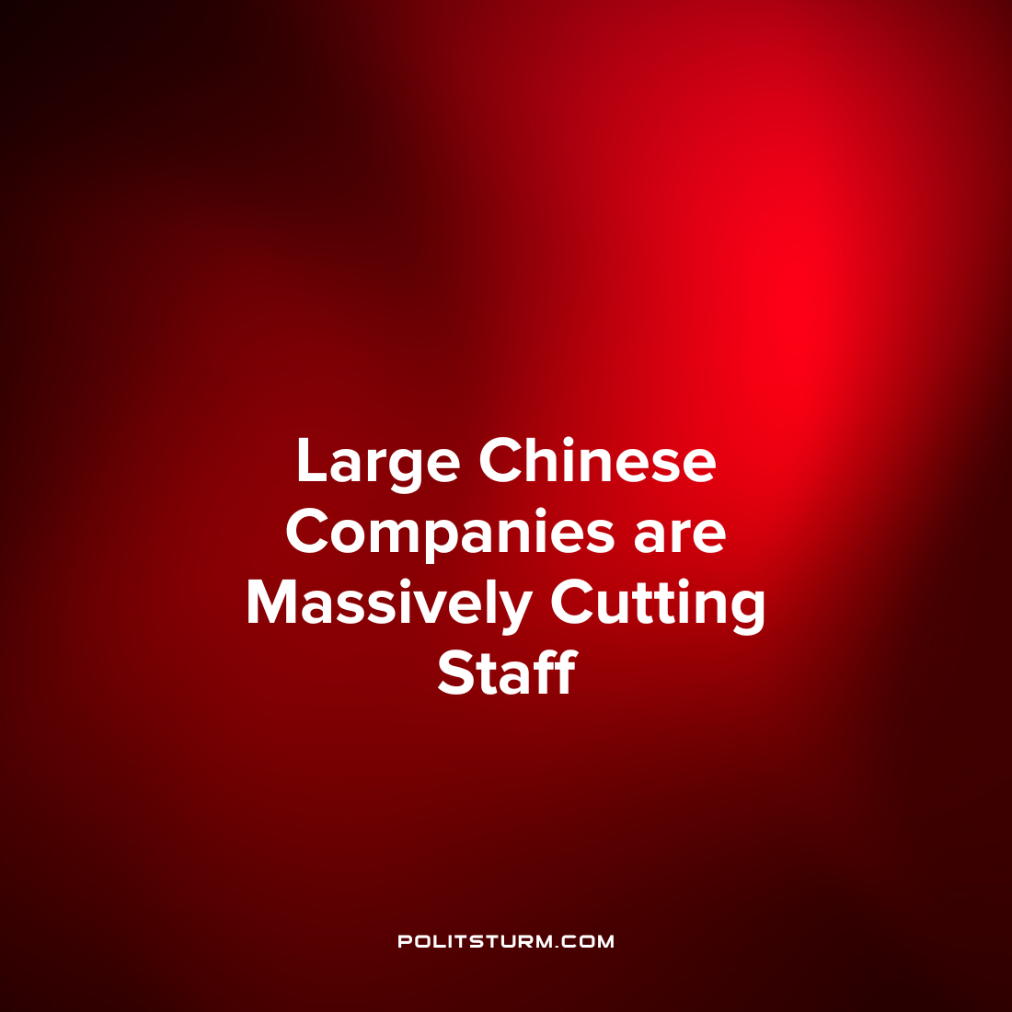

Original article
2022-06-10
1 min read

The South China Morning Post reported that China’s largest technology companies have begun to massively cut their staff.
The fight against coronavirus has caused regulatory uncertainty in the technology sector and a slowdown in economic growth. Against this background, mass layoffs of employees occur. In China, the unemployment rate among people aged 16 to 24 reached 18.2% in April.
Job cuts occur in a wide range of positions. Tencent Holdings media cut 100 people. Consisting of more companies just Tencent, employees are laid off by entire teams consisting of more than 20 people. Alibaba Group Holding is also reducing employees. This will affect the work of such divisions as DingTalk, Alibaba Cloud, Taobao and Taobao Offers.
Tencent President Martin Lau previously stated:

“The company plans to optimize the work of some non-core enterprises in order to control the number of staff. At the same time, the total number of employees by the end of 2022 will still be higher than the previous year.”
Capitalism breeds unemployment. For businessmen, the unemployed are a reserve of labor, which puts pressure on the labor market. This allows you to pay for the ability to work below its cost, which in turn undermines the labor force in the mass. As long as capitalism stands, there will be unemployed people. Only socialism defeats unemployment. Under him, the means of production are in public ownership and serve to meet the needs of the whole society, and not for domination over man.

Original article

