U.K. Labour Party Ends Promise to Repeal Anti-Union Laws
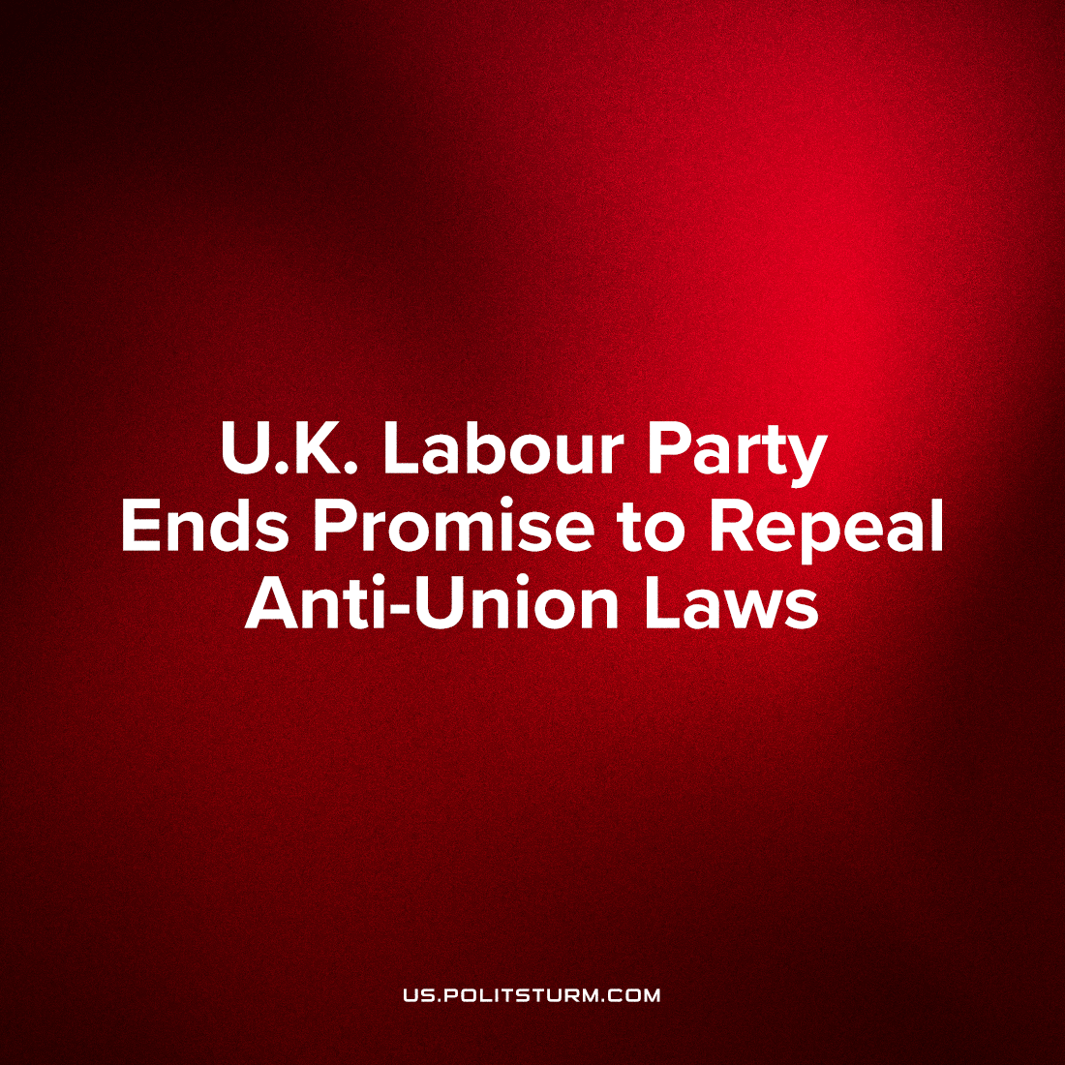

Original article
2023-10-06
2 min read

Current leader of the U.K.'s social-democratic Labour party, Kier Starmer, has announced, during the party's National Policy Forum, that they will not repeal the new anti-Union laws that the Conservative government introduced last year. We have previously covered these anti-union laws. This is only one week after he promise to repeal these anti-union laws at Unite the Union’s union policy conference.
Starmer's reversal of this stance prompted the leadership of two of the largest British unions, Unite the Union and GMB, to walk out of the party forum. Unison, however, another of the largest UK unions, as well as GMB, have since endorsed the policies that were set at that conference after a couple amendments. Only Unite the Union remains to seriously oppose Starmer’s blatantly treacherous policies.
Unite the Union’s leadership previously criticised Starmer’s leadership of the Labour party stating that he “must do better”, and yet the trade union still increases its funding of the party by £1 million a year. Further still, Unite’s leadership banned the viewing of “Oh Jeremy Corbyn – The Big Lie” and Al Jazeera’s “The Labour Files” within Union buildings, two documentaries which discuss the anti-democratic and corrupt inner workings of the Labour party. Unite the Union’s leadership’s excuse to its membership for the ban is “The issues covered in the film are pertinent to internal Labour Party matters and that is not the focus of our union”, which they say as millions in their member's union dues are handed to this political party.
The British Labour movement is the oldest in the world, and its leaders especially have enjoyed a labour-aristocratic share of historic British imperialist plunder and with it a vested order in preserving the status quo. The capitalists of Britain are the most experienced in the world in misleading and deluding workers, and as such varying levels of treachery at every level is the essence of the current British workers’ movement. The level of class consciousness of British workers in generally low, although it is rising as their rights and livelihoods are being openly attacked, but each stage of increased consciousness is met with a new layer of treachery and opportunism, if better veiled. This even extends to what little remains of the Communist movement.
As there is no current party that represents the workers interest to the full extend the main task of communists is to form one. And although it will be difficult, the workers of Great Britain can and must overcome every level of treachery set up to mislead them with guidance and leadership from a genuinely Communist party.
Source: 1, 2, 3, 4, 5, 6

Original article

