Los Angeles Fires Put Out by Firefighters Paid $2 per Hour
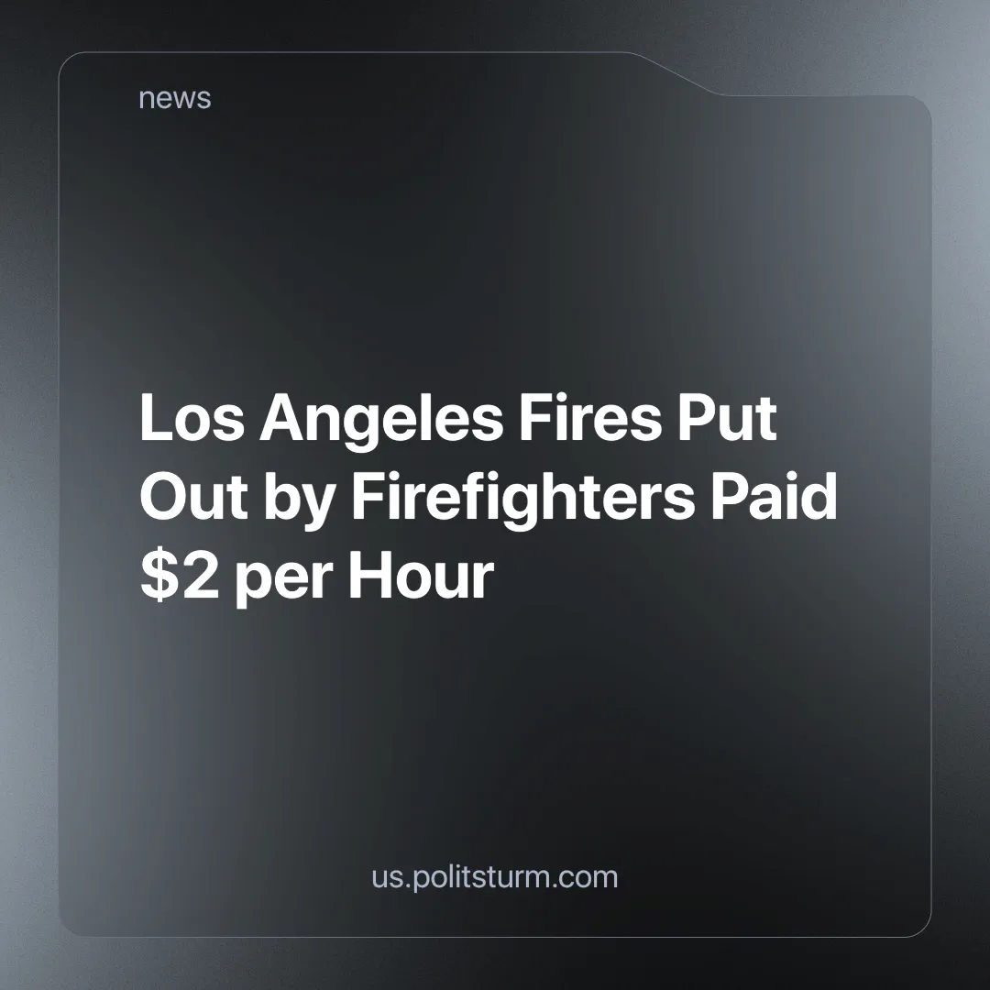

Original article
2025-01-23
4 min read

According to the California Department of Forestry and Fire Protection, over 12 thousand buildings and over 40 thousand acres were burned in what's now been termed “The Greater Los Angeles fires” [1]. Even though so many acres were burnt to the ground, lots of people evacuated from their homes, over 20 fatalities and so many disasters, the fires were eventually put out thanks to the great effort of the firefighters. Fires like this, which used to be freak occurrences have become more and more common thanks to the ongoing and intensifying climate crisis which we have previously written about.
Around 30-40% of the firefighters in California are low-level felons, who volunteered to help the fire department with the fires. What really caught the attention of the media were their paychecks. Prisoners earn 2 dollars per hour for the dangerous and hard job that they are doing. And the worst thing is, that 2 dollars per hour is considered a good wage for prisoners, as the average wage in US prisons is less than a dollar per hour [2].
One might ask “Well what’s the problem? They don’t need the money for rent, food or medicine, since the prisons already provide that. Why do they need high wages, considering the fact they are also serving a sentence for a crime they’ve committed”, but the devil is in the details. Over 45% of the inmates in state prisons and over 55% in the state prisons are parents of minors (under 18) who depend on them as the state provides very little or no financial help to these children [3]. Almost 3 million children have at least one of their parents in prison and over 5 million people have had their parents imprisoned at some point in their lives.
Under capitalism, prisons have always been a tool of class domination. In a world where there are two classes, the workers and the capitalists, the oppressors and the oppressed, the prison system is far from the “administrative justice” that the media and the state portray it as, but a tool of oppression and control used by the exploiting minority to put pressure on the oppressed majority that struggles to survive. The state itself is not a neutral body or “fair” arbiter of interests within but inevitably serves the interests of the ruling class, as the capitalists are the only ones with the means to spend millions on lobbyists, political campaigns and media companies. With the police as their army against the people, prisons serve as just one more tool of control. We have previously expanded on the role of the police in our earlier article.
History has shown us multiple examples of prisons being used as a way to oppress people. Julian Assange, who was arrested for “treason” after leaking the US war crimes during the invasion of Iraq, Eugene Debs, who was sent to arrested and harassed by police for opposing war, Angelo Herndon, who was sent to jail while organizing workers in Atlanta, and many others were imprisoned for fighting for the working class interests and exposing the crimes of the US ruling class. In fact the US has the highest prison population in the world [4]
The minimum remuneration required for living and affording basic necessities in California (food, rent, utilities etc.) for 1 adult with a child is $26 (after tax) per hour, under the condition that they’re in a family with both parents (meaning themself and their partner) working. But that’s to afford a minimum living standard for themselves and the child. A wage of $6 (after tax) per hour, with both parents working, is considered a poverty wage all across California [5]. The prison wages are so low, that they aren’t enough to even keep the prisoners out of poverty, let alone to help their families outside to make ends meet. And the prisoners aren’t doing easy jobs, being a firefighter is one of the hardest and most dangerous jobs out there. These people risk their lives for $2 per hour, while people like Elon Musk, who lock themselves in their multi-million dollar mansions, do little to no work and “earn” $537 per second. One might ask, “But what could be the alternative?”
Under socialism, where the means of production are owned by society and controlled by the very workers, the prison system would protect the workers from crimes, with their goal being the rehabilitation of the prisoners into normal working life. The prison system would contribute to the class struggle against capitalistic oppression and would not be a part of the oppression.
We strongly advise you, the reader, to not let the liberal media gaslight you into alienating yourself from the inmates, as they are mostly people like you, with the same wants and needs as you. What benefits most incarcerated people in the US, in the end, will benefit the working class as well. And the crimes they have committed in the past should not let you think of them as lesser human beings, because the majority of crimes committed are property crimes like petty theft or burglary, made by people trying to get money for their families in order to survive and resorting to crime, as there were no legal options to get adequate living conditions.
Under capitalism, capitalists are stealing the majority of labour done by workers in the form of surplus value, put regressive tax laws (large taxes on the working class, small taxes on the rich) on the population by lobbying parties in power, so it is not surprising why so many people are left with few options but to commit crimes to put food on the table. In order to have socialism we need a strong communist movement and party, however, none such exists in the US and most countries around the world. The task of communists is to build such a party and we are involved in this - join us.
Sources
[1] California Department of Forestry and Fire Protection — Current Emergency Incidents — January 21st, 2025
[2] Mother Jones — 30 Percent of California’s Forest Firefighters Are Prisoners — August 15th, 2014
[3] The Sentencing Project — Parents in Prison — September 2022
[4] Worldostats — Imprisonment Rate by Country 2025 — January 2025
[5] Living Wage Calculator — Living Wage Calculation for California — February 24th, 2024

Original article

