L.A. Workers Facing Wave Of Evictions &amp; Homelessness
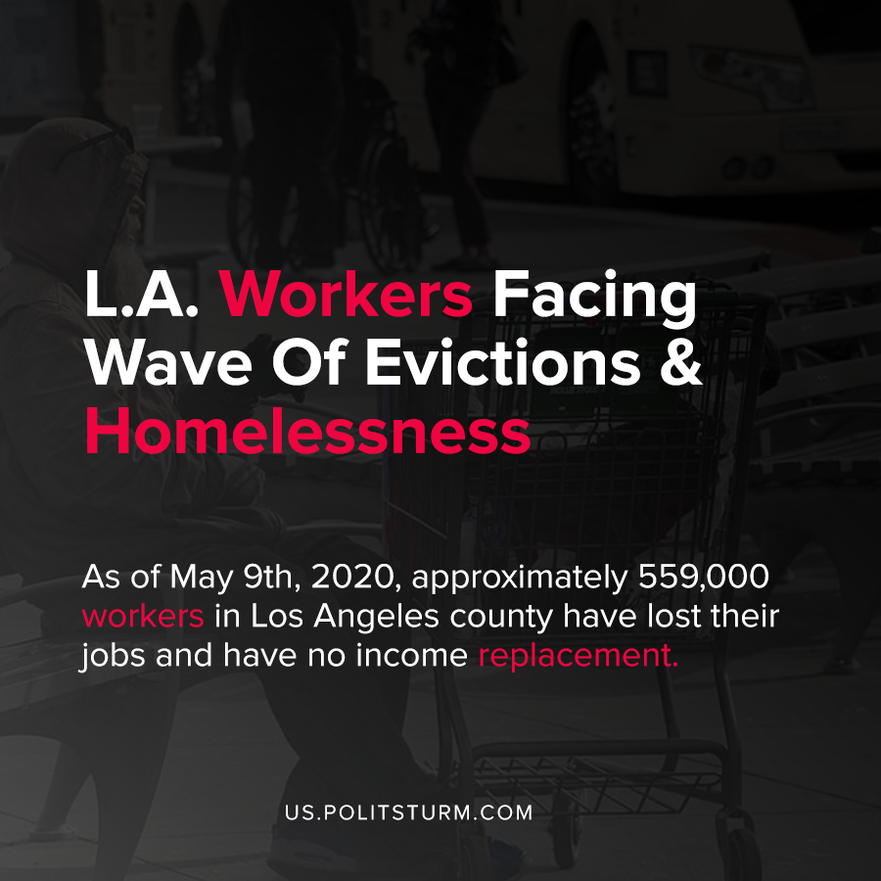

Original article
2020-08-30
1 min read

A tsunami of evictions is forthcoming in Los Angeles, according to UCLA Professor Gary Blasi, which will inevitably lead to increasing homelessness. According to the professor, Los Angeles has the second-highest urban rents in the United States, coupled with increasing rates of joblessness.
As of May 9th, 2020, approximately 559,000 workers in Los Angeles county have lost their jobs and have no income replacement. In addition, the vast majority of those affected do not have savings or any resources to pay the rent.
Over half a million children live in households that would be affected by eviction. Taking into consideration all of these factors, the professor predicts a situation of widespread homelessness unless the current situations change.
Under capitalism, there is a market for both labor power and housing. When periodic crises of overproduction occur, workers who lose their jobs also lose their income and the ability to pay rents to the private owners of housing units.
Landlords and real estate investors are interested in rents and profit and when workers lose their jobs through no fault of their own, they are subject to eviction. As a result, the problem of homelessness cannot be resolved within the framework of the capitalist system.
As long as the ownership of the means of production and housing are a private affair, the market will periodically subject the workers to joblessness and homelessness. Only through an understanding of Marxism-Leninism by the working class and through the institution of public ownership of the means of production can the problem of homelessness and poverty be ultimately resolved.
Sources: 1 , 2

Original article

