Lenin on the Break Down of National Barriers
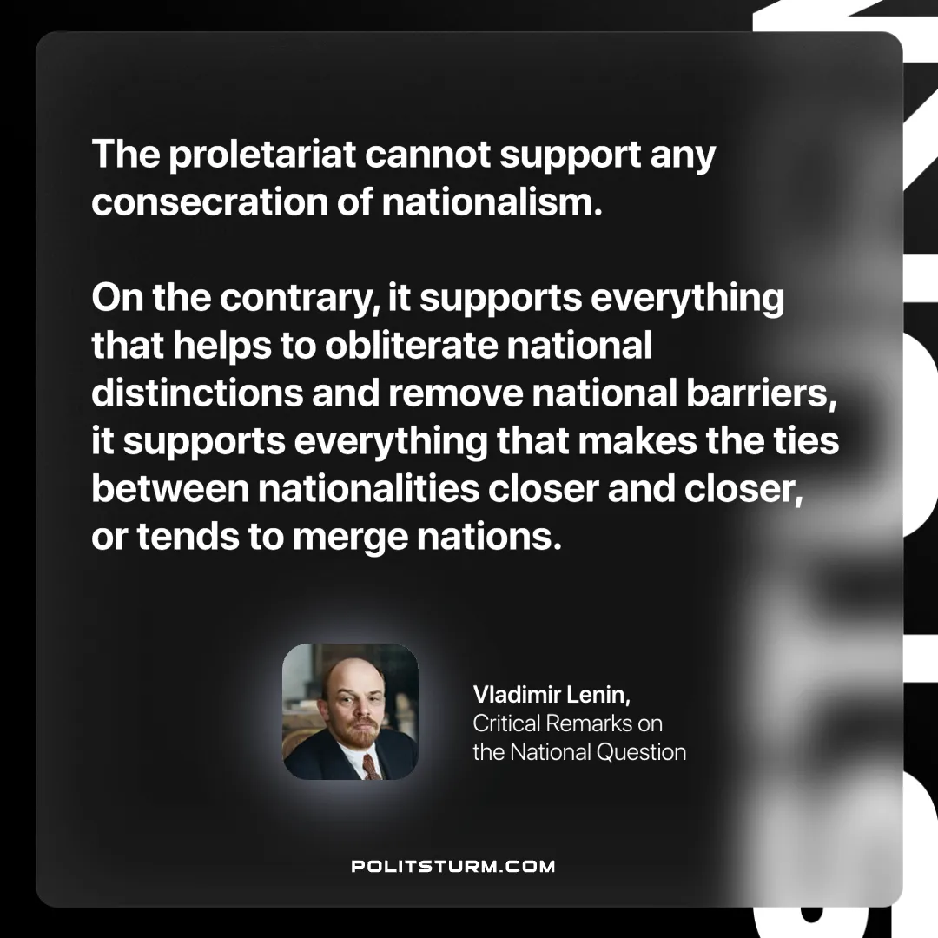

Original article
2024-12-08

“The proletariat cannot support any consecration of nationalism; on the contrary, it supports everything that helps to obliterate national distinctions and remove national barriers; it supports everything that makes the ties between nationalities closer and closer, or tends to merge nations.”
Vladimir Lenin, Critical Remarks on the National Question

Original article

