Lenin on the Hatred of the Oppressed Nation towards the Oppressor Nation
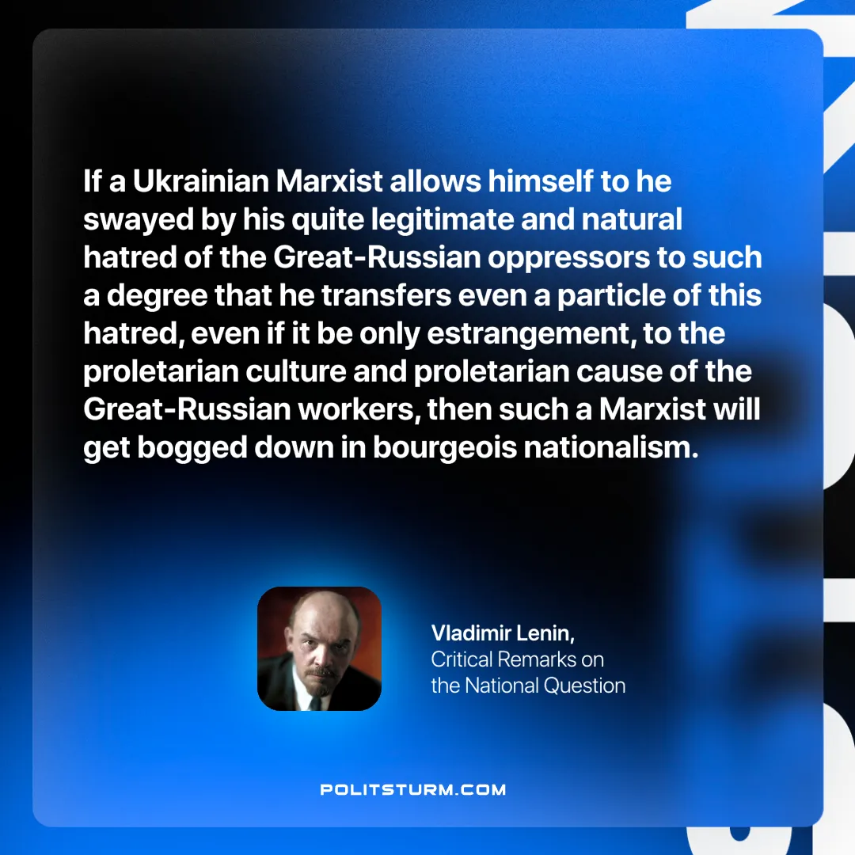

Original article
2024-10-10

“If a Ukrainian Marxist allows himself to he swayed by his quite legitimate and natural hatred of the Great-Russian oppressors to such a degree that he transfers even a particle of this hatred, even if it be only estrangement, to the proletarian culture and proletarian cause of the Great-Russian workers, then such a Marxist will get bogged down in bourgeois nationalism.
Vladimir Lenin, Critical Remarks on the National Question.

Original article

