Lenin on the Main Task of the Revolutionary Party
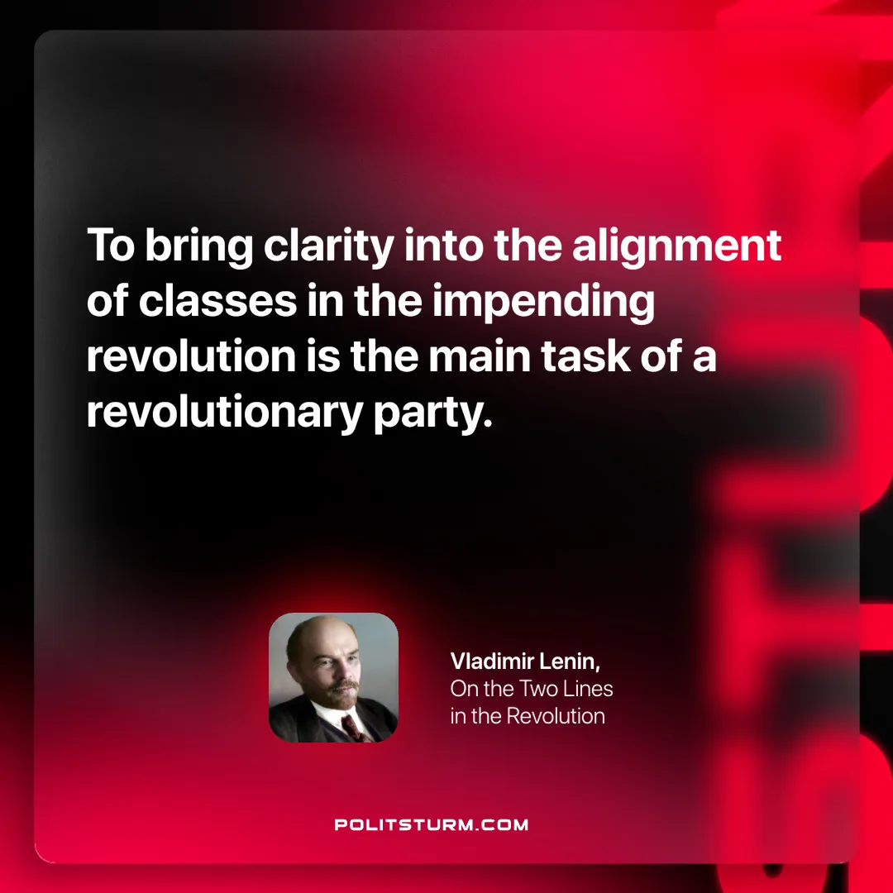

Original article
2025-04-08

“To bring clarity into the alignment of classes in the impending revolution is the main task of a revolutionary party.”
Vladimir Lenin, On the Two Lines in the Revolution

Original article

