Kyrgyzstan Exonerates The Anti-Communists
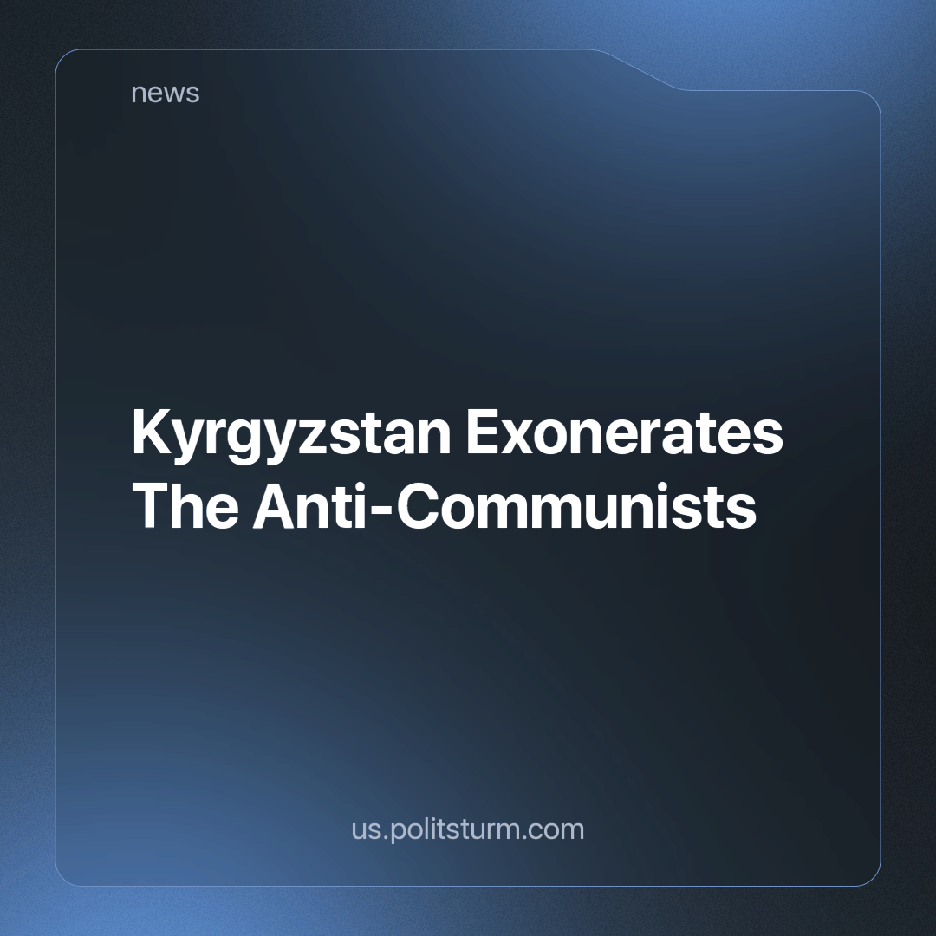

Original article
2023-10-31
2 min read

Kyrgyzstan lags behind neighboring countries in rehabilitating victims of political repression. This was reported during a meeting of the parliamentary committee on social policy in which Deputy (legislator) Jeanar Akaev presented a draft law in its first reading. The draft law envisages amendments to the laws 'On the Rights and Guarantees of Rehabilitated Citizens Affected by Repression for Political and Religious Beliefs, Social, National, and Other Characteristics' and 'On the National Archive Fund of the Kyrgyz Republic.'
The law proposes to add a new article stating that individuals who were convicted under certain articles of the Criminal Code of the RSFSR from 1922 and 1926, which were in effect in Kyrgyzstan until 1961, shall be considered to have been subjected to political repression.
According to the draft law, signs of political repression include decisions made by the authorities based on resolutions related to the 'Red Terror', directives on combating the Basmachi movement, resolutions on state crimes, indications of kulak households, as well as several other decisions issued by the Soviet authorities.
"Our ancestors were executed, sent into exile, arrested, and imprisoned. Our mission is to carry out political rehabilitation. On this issue, we are significantly behind the Central Asian states. In Uzbekistan, a special commission was created by presidential decree. As a result of its work, the victims of repression have been exonerated. In Kazakhstan, around 360,000 people have been exonerated. Kassym-Jomart Tokayev engaged 400 researchers for this purpose and personally allocated funds from the budget. They allocate about $3 million annually," said Jeanar Akaev.
The bourgeoisie aims to tarnish the first socialist state using cinema, television, music, books, games, and mass media to create various myths about the Soviet Union. One of the capitalists' favorite themes is the years 1937-38 in the history of the USSR when the 'bloody Cheka' allegedly sent people to their deaths in labor camps for no reason.
This highlights the common tendency of the bourgeoisie in all former Soviet republics to blacken the once-unified socialist past. Instead of producing an objective assessment of these events based on scientific research, they lie by portraying all those repressed as innocent victims of a 'bloody' regime and, under this pretext, whitewash the Basmachi, Kulaks, and Bais*.
We will not receive an objective assessment from the capitalist authorities, but we must understand and correctly assess the class nature of governments' attempts to rehabilitate those convicted during the 1937-1938 Soviet period. The modern ruling elite, protecting the interests of the wealthy, needs the existing dominance of private property and the market to remain unchallenged. They are doing their utmost, using various means, to turn the common people against a past where speculation and exploitation were illegal. At that time, crimes against the world's first just society, in which workers' power reigned supreme, were severely punished. Today’s masters are deeply afraid that their rule will come to an end. They vehemently oppose a potential return to a system where labor is no longer oppressed and the power of capital does not reign.
*Bai (Бай in cryllic) is a Kazakh word meaning “rich landlord or merchant”.
Source: 24.kg - “Deputy proposes to rehabilitate victims of political repression” dated September 18, 2023.

Original article

