Konstantinov on the Peoples of Russia
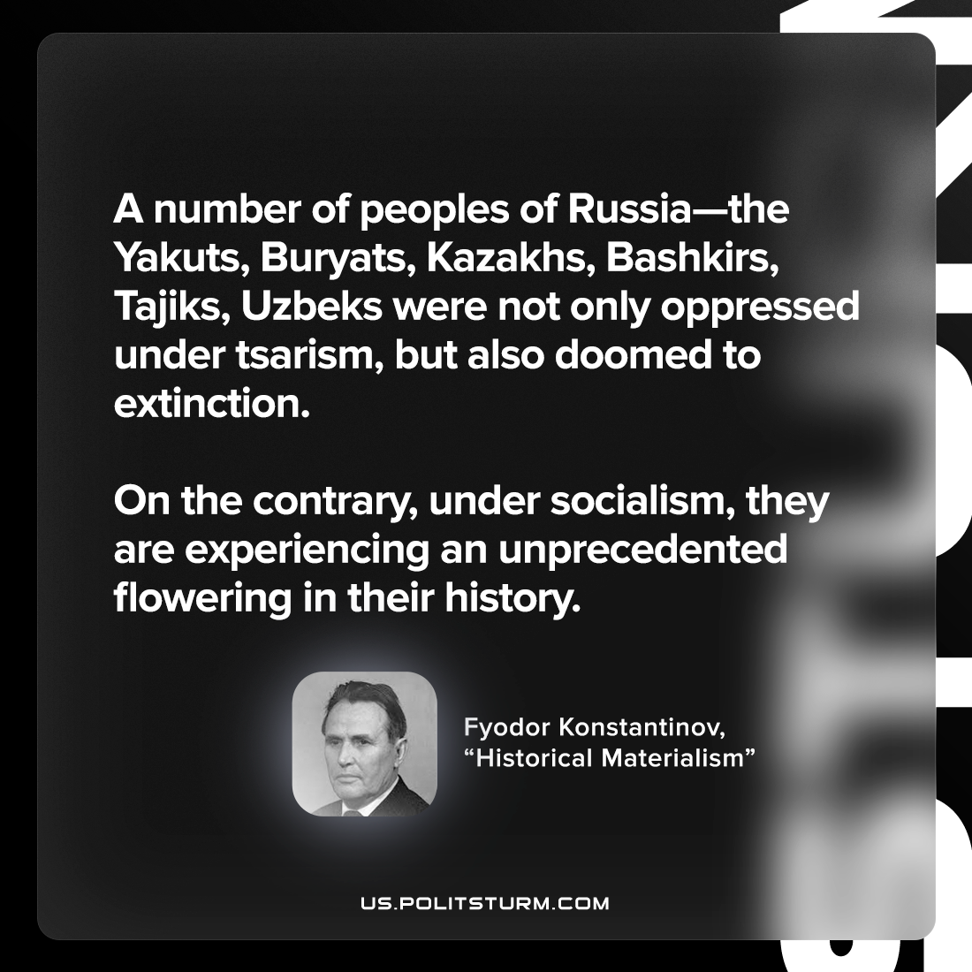

Original article
2022-11-01

A number of peoples of Russia—the Yakuts, Buryats, Kazakhs, Bashkirs, Tajiks, Uzbeks were not only oppressed under tsarism, but also doomed to extinction. On the contrary, under socialism, they are experiencing an unprecedented flowering in their history.

Fyodor Konstantinov, “Historical Materialism”

Original article

