Konstantinov on the Essence of the Capitalist State
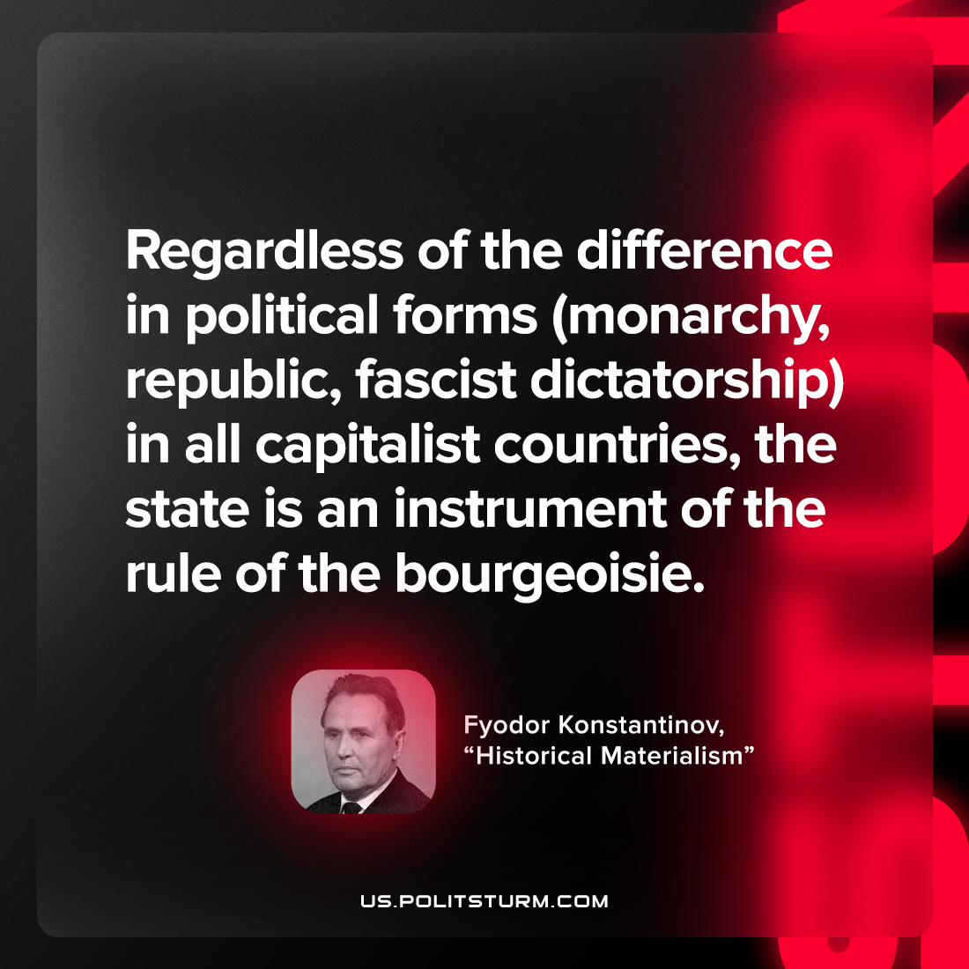

Original article
2022-09-19

Regardless of the difference in political forms (monarchy, republic, fascist dictatorship) in all capitalist countries, the state is an instrument of the rule of the bourgeoisie.

Fyodor Konstantinov, “Historical Materialism”

Original article

