Konstantinov on the Difference of Capitalist and Soviet Societies
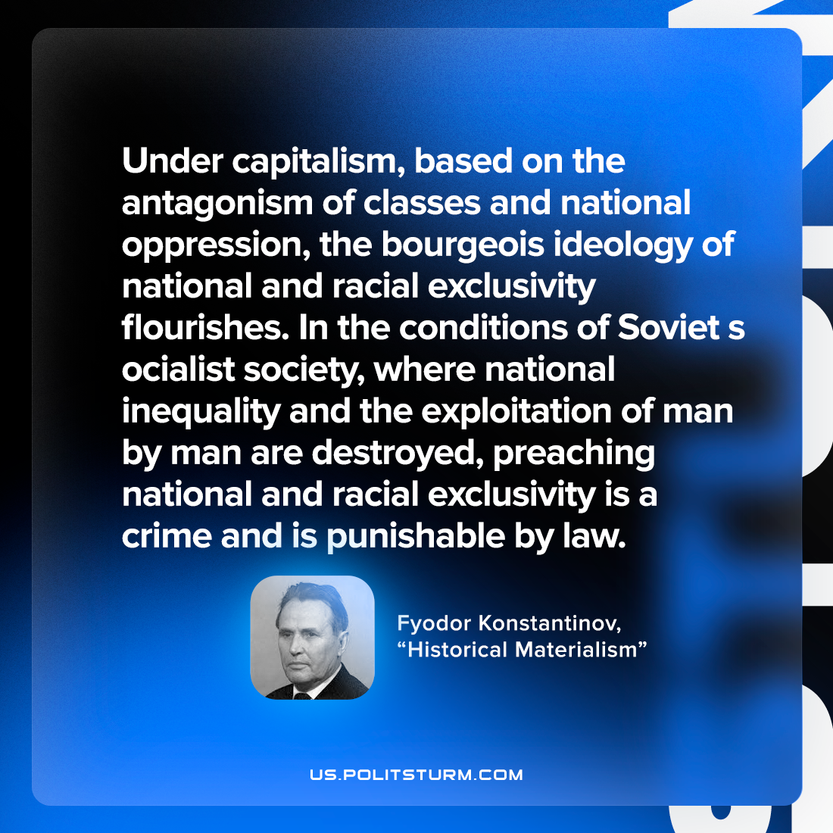

Original article
2022-09-09

Under capitalism, based on the antagonism of classes and national oppression, the bourgeois ideology of national and racial exclusivity flourishes. In the conditions of Soviet socialist society, where national inequality and the exploitation of man by man are destroyed, preaching national and racial exclusivity is a crime and is punishable by law.

Fyodor Konstantinov, “Historical Materialism”

Original article

