Konstantinov on Sources of Problems
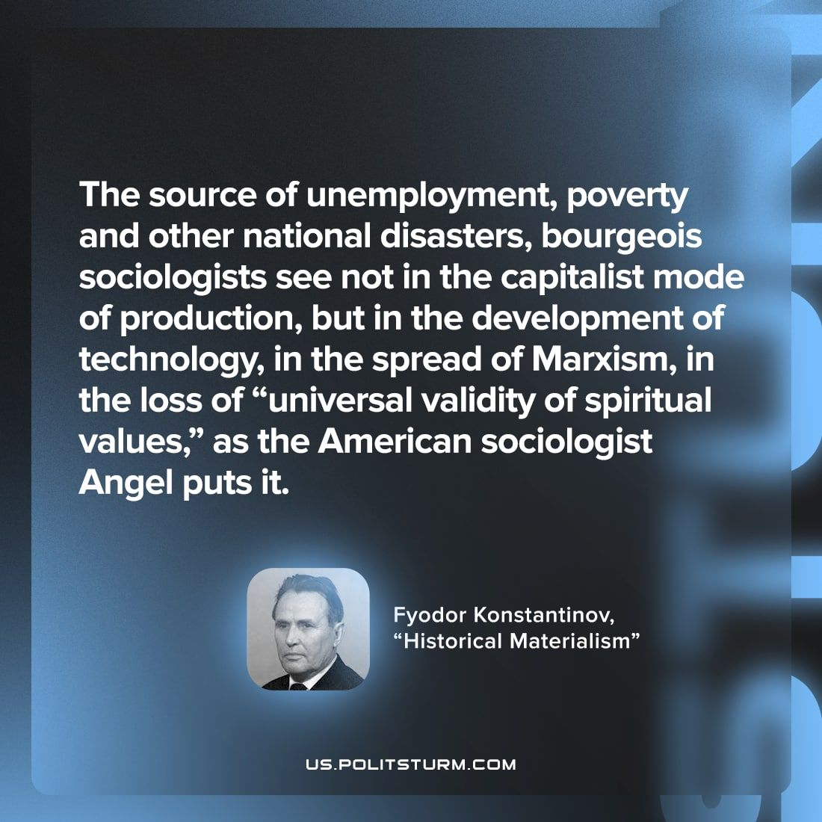

Original article
2022-12-03

"The source of unemployment, poverty and other national disasters, bourgeois sociologists see not in the capitalist mode of production, but in the development of technology, in the spread of Marxism, in the loss of "universal validity of spiritual values," as the American sociologist Angel puts it"
Fyodor Konstantinov, "Historical Materialism"

Original article

