Konstantinov on the Origin of the Superstructure
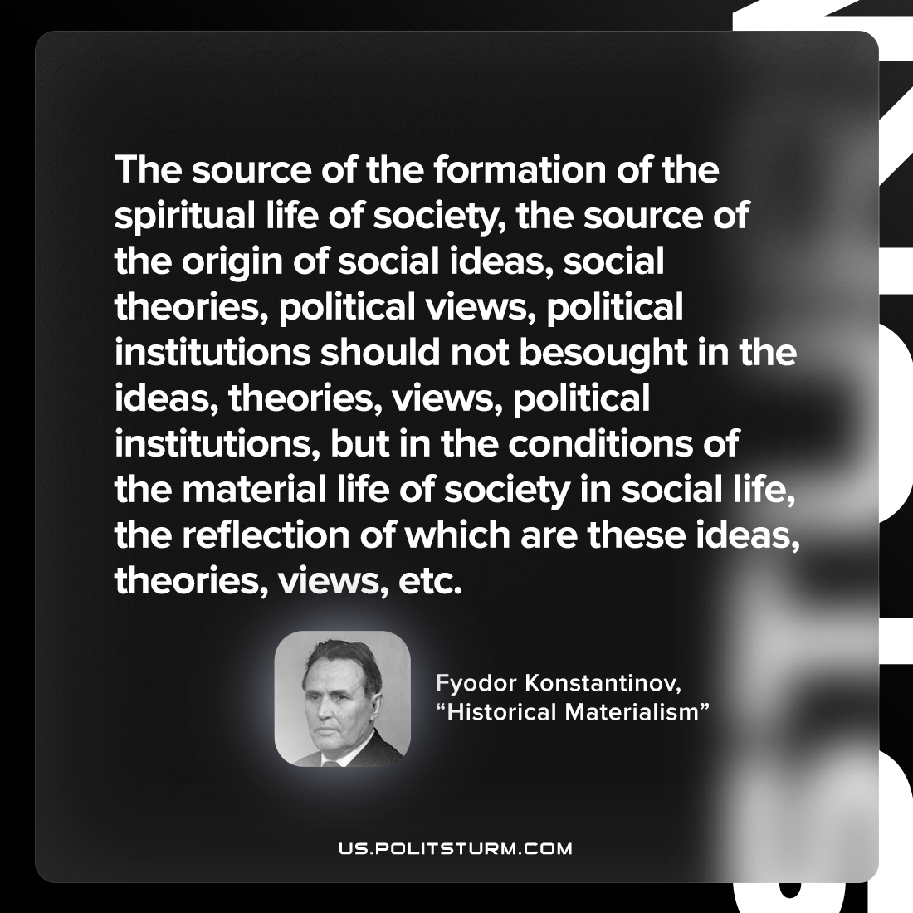

Original article
2022-08-29

The source of the formation of the spiritual life of society, the source of the origin of social ideas, social theories, political views, political institutions should not be sought in the ideas, theories, views, political institutions, but in the conditions of the material life of society in social life, the reflection of which are these ideas, theories, views, etc.

Fyodor Konstantinov, “Historical Materialism”

Original article

