Konstantinov on Masses Spreading Consciousness
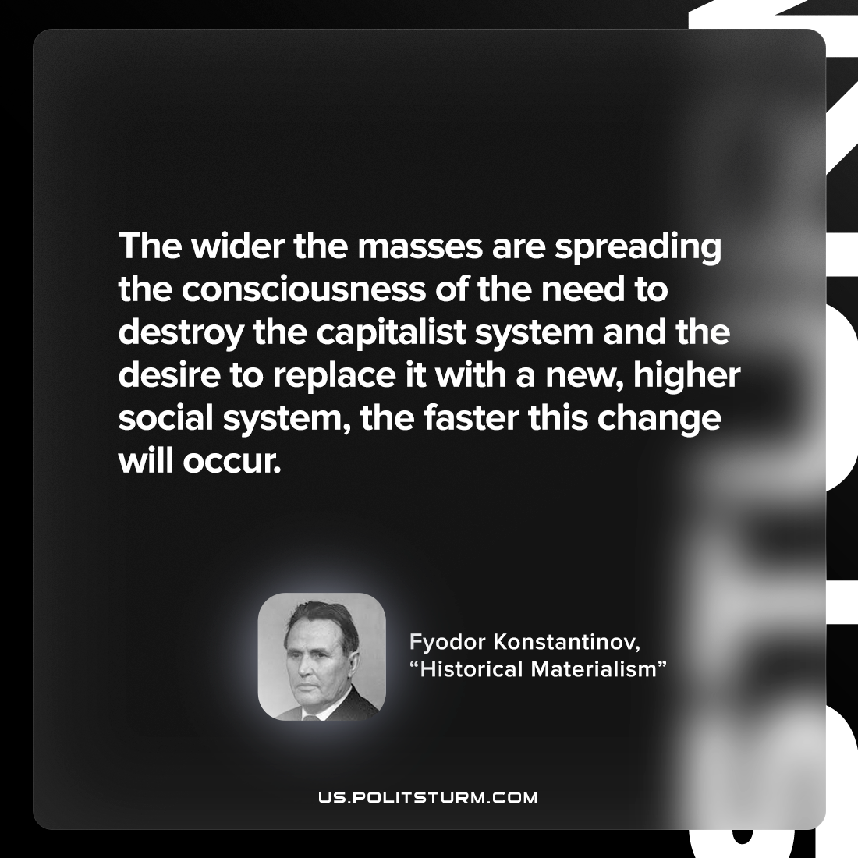

Original article
2022-10-09

The wider the masses are spreading the consciousness of the need to destroy the capitalist system and the desire to replace it with a new, higher social system, the faster this change will occur.

Fyodor Konstantinov, “Historical Materialism”

Original article

