Konstantinov on Marxist-Leninist Science
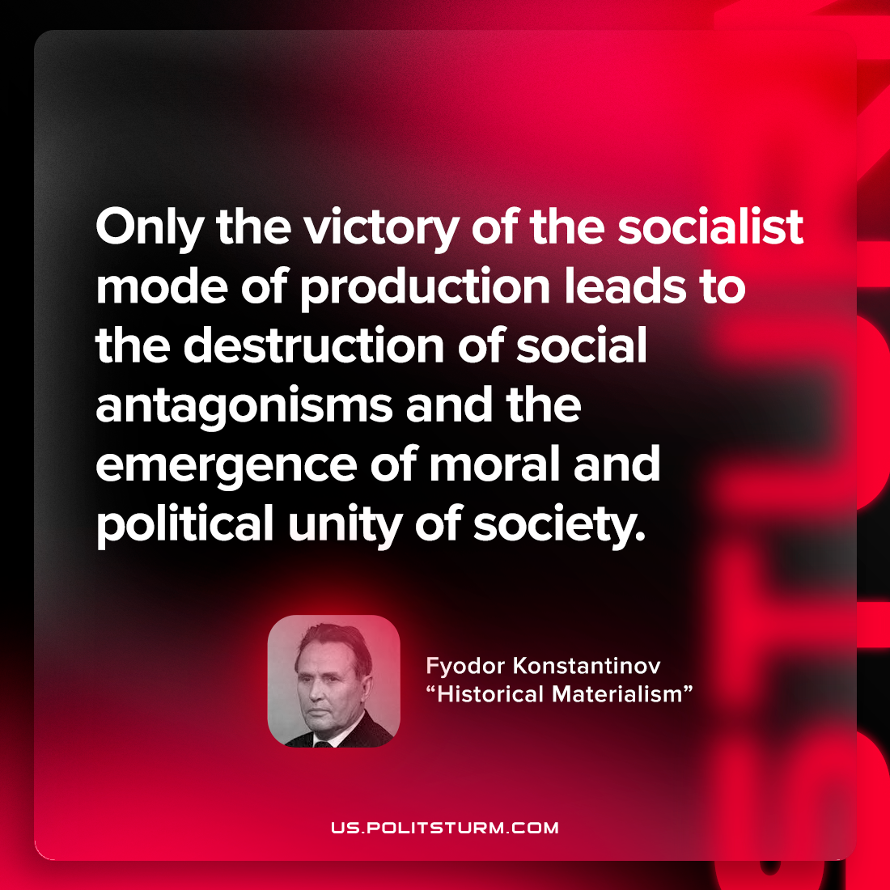

Original article
2022-09-17

Only the victory of the socialist mode of production leads to the destruction of social antagonisms and the emergence of moral and political unity of society.

Fyodor Konstantinov, “Historical Materialism”

Original article

