Koch Foundation Influences George Mason University Employment
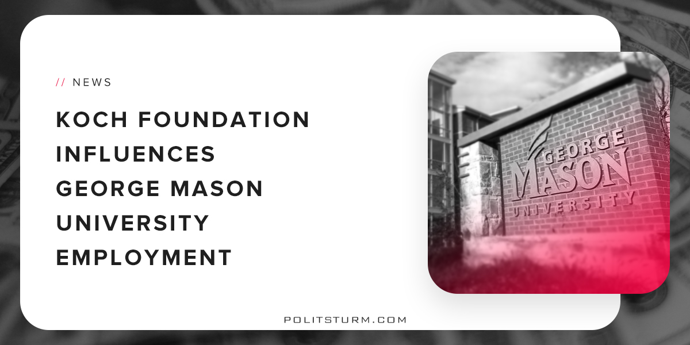

Original article
2018-05-08
2 min read

In the German Ideology, Karl Marx famously stated that the ideas of the ruling class “in every epoch are the ruling ideas.” In the United States today, we see this manifested in the number of millionaires who occupy seats of governmental power, the swarm of lobbyists buying up favorable legislation for their bourgeois clients, social and mass media outlets disseminating the worldview of the powerful, but even in everyday institutions that most would not think of as political playing fields, there is the constant pressure to promote an ever friendlier face to the free market.
This has been the case at Virginia’s largest public university as was revealed last April. Leaked donor records show that despite denials from the university administrators, George Mason University permitted the far-right Charles Koch Foundation a say in the hiring and firing of professors at the university, in exchange for millions in donations. The documents revealed agreements that allowed the foundation to choose two of the five members of the five-member selection committee who choose professors for the university’s free-market Mercatus Center.
Other sections of the agreement provide for the renaming of the law school at George Mason after conservative Supreme Court Justice Antonin Scalia. $10 million donations were made on behalf of the Koch foundation with another $20 million from an anonymous donor.
The documents were released to Samantha Parsons, a former student of George Mason, under a Freedom of Information Act request filed this year after past requests had been denied. An anti-Koch activist, Parsons claims that the agreement is similar to one signed by Florida State University.
Redacted emails show Leonard Leo, executive vice president of the conservative Federalist Society, to be one of the representatives of the Koch Foundation. The emails reveal that Leo was constantly in touch with the dean over faculty hires and student admissions. In a 2015 email, Leo notified the dean about a student from the Republican Attorney General Association who was applying for admissions and asked if he would meet with the student, to which he replied, “Absolutely! I will work with the admissions office to make sure we get together.”
For all the talk of attacks on free speech on the right side of the aisle, crickets seem to be chirping when wealthy donors meddle in public discourse. Of course, as much as they complain about imaginary “safe-spaces” and political correctness, they only care about free speech so long as it benefits themselves. Likewise with the “resistance” liberals who gawk over the damage that Trump is doing to “media freedoms.” The fact that the richest few in the United States can so heavily influence political discourse on a systemic level is lost on them. What we should be asking ourselves is not whether free speech is threatened by wildly distorted cases of “social justice warriors” but rather by the corporate influence that props up the ideas of the wealthy? Is it possible for there be a true “marketplace of ideas” in an arena where the pro-market “product” has infinitely more resources at its disposal?
Sources: 1, 2

Original article

