Kellogg Cereal Production Plants Are On Strike
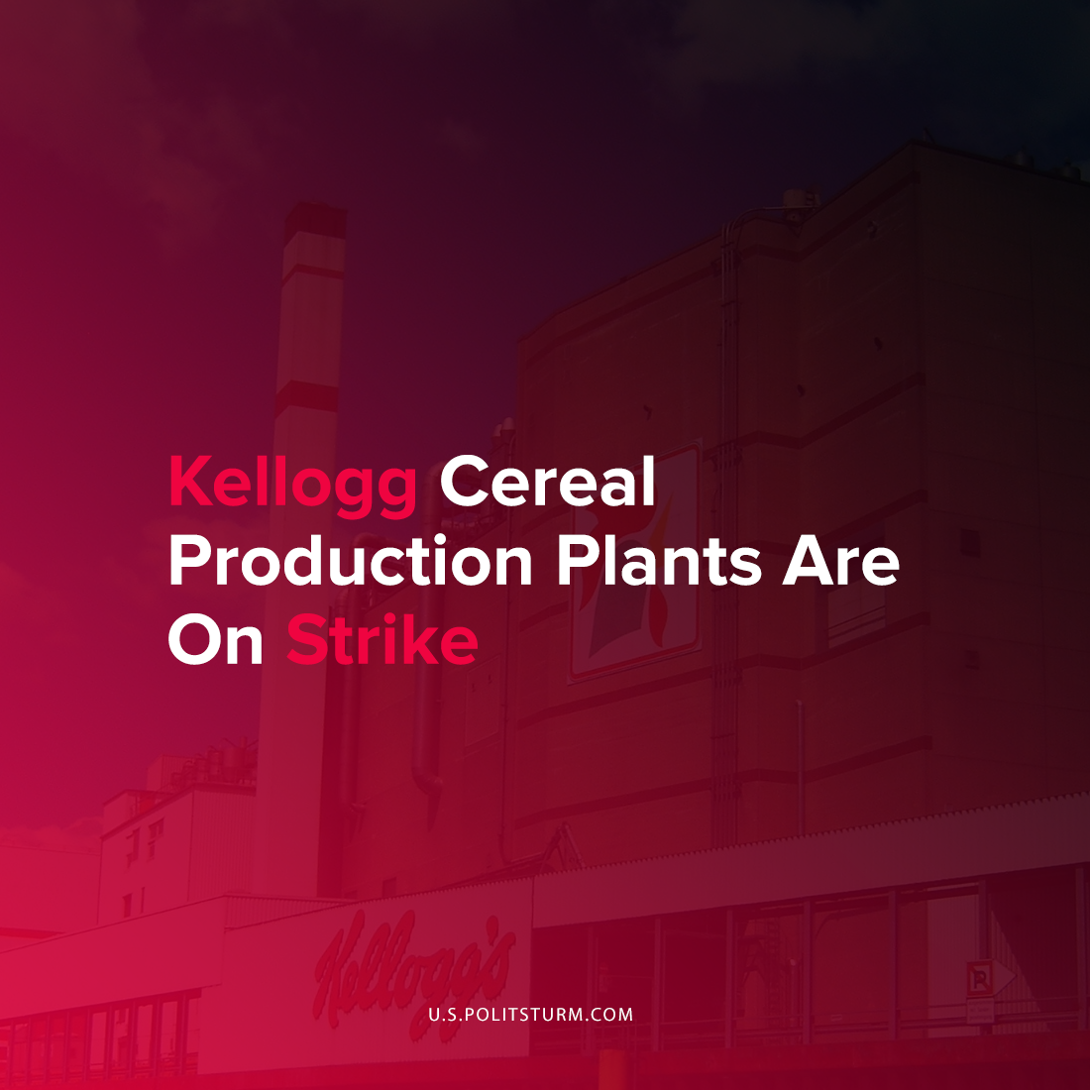

Original article
2021-10-09
1 min read

Kellogg workers across the United States are striking in response to a reduction of benefits and cost-of-living wage increases. The company has also proposed moving production lines from the U.S. to Mexico and implementing a two-tiered employment system.
According to the Bakery and Confectionery Workers International Union of America representing the workers, the proposed system would have new hires making less in wages and would not have the ability to receive a pension. Also, 30% of the current workforce would pay higher costs for healthcare and would lose access to retirement benefits.

“For more than a year throughout the COVID-19 pandemic, Kellogg workers around the country have been working long, hard hours, day in and day out, to produce Kellogg ready-to-eat cereals for American families. Kellogg’s response to these loyal, hardworking employees has been to demand these workers give up quality health care, retirement benefits, and holiday and vacation pay. The company continues to threaten to send additional jobs to Mexico if workers do not accept outrageous proposals that take away protections that workers have had for decades.”
-BCTGM

Regardless of the conditions, capitalists will try to undermine any worker benefits to benefit the class of oligarchs. Companies are only aimed at maximizing their profits and the accompanying exploitation of labor. It is necessary for the working class to organize against the capitalists by fully understanding Marxist-Leninist principles and ending the systematic oppression that occurs under capitalism.
Source: 1 2

Original article

