Karl Marx – 205th Anniversary
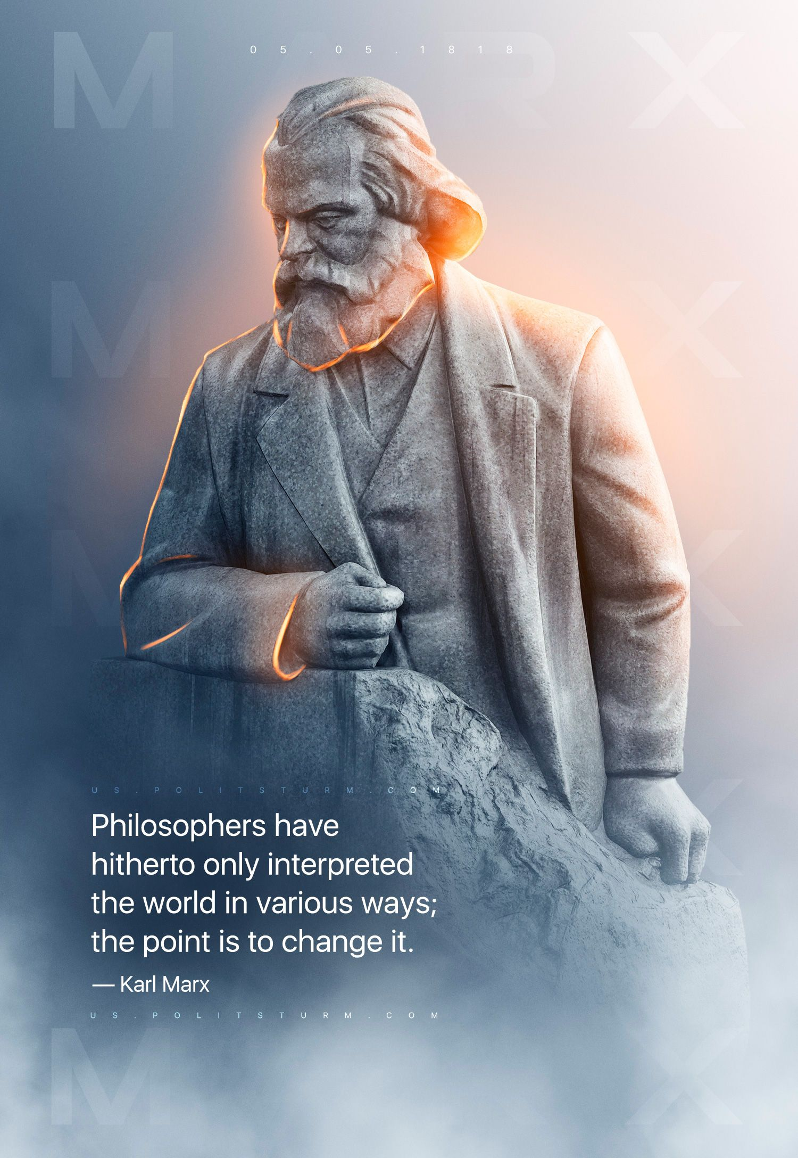

Original article
2023-05-05
1 min read

The genius of Marx consists precisely in his having furnished answers to questions already raised by the foremost minds of mankind. His doctrine emerged as the direct and immediate continuation of the teachings of the greatest representatives of philosophy, political economy and socialism.
The Marxist doctrine is omnipotent because it is true. It is comprehensive and harmonious, and provides men with an integral world outlook irreconcilable with any form of superstition, reaction, or defence of bourgeois oppression. It is the legitimate successor to the best that man produced in the nineteenth century, as represented by German philosophy, English political economy and French socialism. – Vladimir Lenin, The Three Sources and Three Component Parts of Marxism.

Original article

