Rapper Kanye West Spearheads Fascist Clique
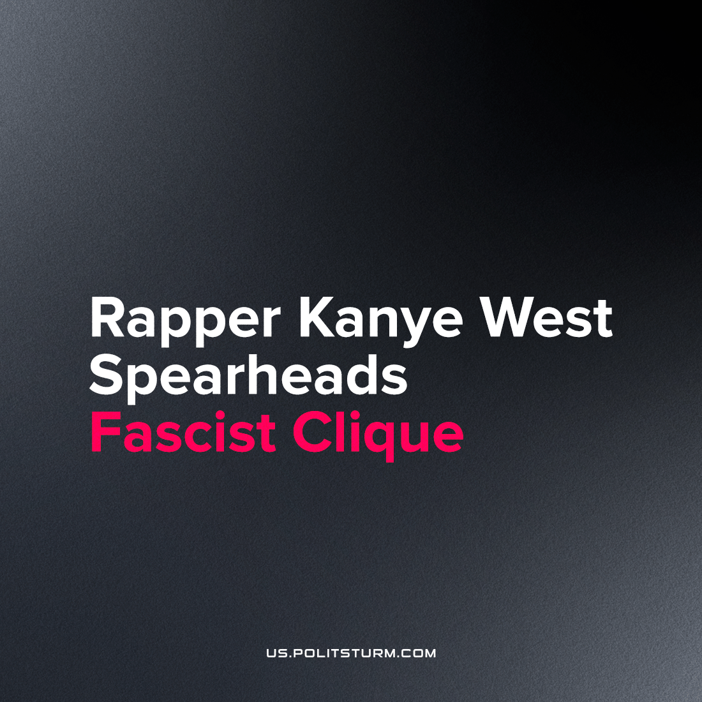

Original article
2022-11-29
2 min read

In recent weeks, one of the world’s biggest media personalities, Kanye West, or Ye, lost sponsorship from several companies over his vocal embrace of open antisemitism, and otherwise his alignment with the far-right of American politcs. While West’s support for Donald Trump has been an object of spectacle since 2016, and West has often mentioned his interest in running for President, these political possibilities have not risen into a serious position until now.
Last week, after announcing his own presidential run in 2024, Donald Trump met with Kanye West at an arranged dinner to largely try and win over the musical star to the idea of running as Trump’s Vice President. From the resulting fallout, Trump would claim that he did not know who Kanye would bring with him to that dinner.
Nick Fuentes is a neo-fascist personality who has long occupied a cultural niche online by advocating the most extreme, open reaction of misogyny, and particularly racism and antisemitism. He maintains his position over years by remaining devoted to the most hardcore nazi elements of online society, emerging from sites such as 4chan, 8chan, and neo-nazi chat rooms.
In a subsequent interview with older alt-right celebrity Milo Yiannopolis, Kanye claimed that Trump was ‘very impressed’ with Fuentes. Luckily, Kanye and Trump’s political fortunes together are dim.
However, Kanye has not ceased leading the most marginal and barbaric reactionaries in the public sphere to advocate for the place of the most extreme Jewish Conspiracy positions as its strongman and greatest possible advocate.
The Tim Pool show proudly advertised the scheduled of appearance of Kanye, Milo, and Nick Fuentes together in one broadcast, in what would have likely been a particularly successful episode - with Kanye's broad fame bringing in new audiences of the rapper's older and non-white followers which would otherwise overlook a show like Pool's. Tim Pool himself appeared numerous times on the Joe Rogan show, the most popular broadcast in the English-speaking world with an average audience of over 11 million. Over the past couple years, Pool has more and more embraced the forms of extreme reaction demanded as planks of 'Kanyeism': anti-woman and anti-abortion sentiment, and an anti-LGBT position expressed in support for the murder of gay and trans people at recent the Club Q shooting.
After 20 minutes, the following interaction took place after the "Jewish Question" came into conversation.
N. Fuentes: “It is them (Jews) though, isn’t it?”
T.Pool: “No.”
K.West: “What do you mean it’s not?”
With that, West left the interview, seen in the video walking behind Pool and out the door of the recording studio without a second word. Both Milo and Fuentes followed shortly after the rapper, knowing full-well where their lunch ticket is found, ruining Pool’s hyped-up broadcast.
West's cohort pack spectacle upon spectacle, reaffirming their own credibility and the image of a genuine, impassioned believer who holds his pure beliefs above the cynical adoption of repugnant views by such media types as Pool. This benefits both Pool's place in mainstream, liberal and libertarian political media, and the continued endeavor of the rapper's antisemitic quest for a suitably reactionary space.
Kanye West will continue to feed his new alt-right parasites as long as he wants them around and they can successfully submit themselves to his shifting mood. Acting as a figurehead for these elements, he can bring a fascist project to the discursive forefront, validating these tenets of fascist belief in the eyes of millions of conservatives currently lost in the contradictions within that movement. Despite the marginal origins of Fuentes and Yiannapolis, they have been floated down the stream of culture by forces and interests larger than themselves, to advance the fascization of society and the political position of the ruling class.
Sources: 1, 2.

Original article

