Kamo: A Story of Stalin's Student and Armenian Revolutionary
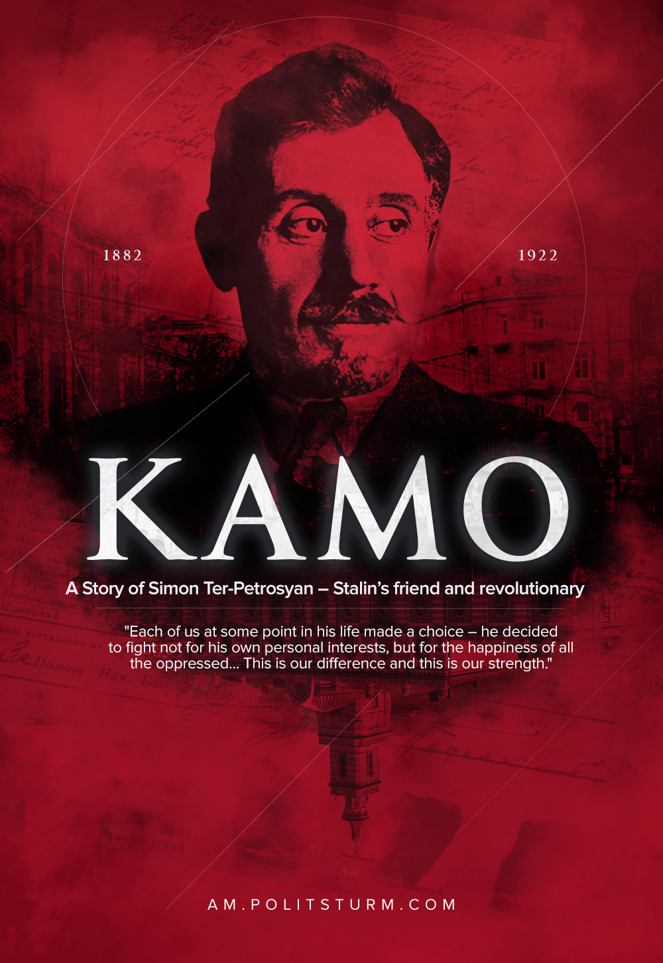

Original article
2021-11-03
6 min read

Simon Arshakovich Ter-Petrosyan was born on May 27, 1882 in Gori. The future revolutionary was born into a merchant family.
As Kamo wrote, the father, Arshak Ter-Petrosov, was a petty tyrant, so there was anger and hatred in the family. Despite the fact that parents and elders are treated with respect in the Caucasus, Simon was ashamed of his father. Comparing his parent and Joseph Stalin‘s father, Vissarion Dzhugashvili, Kamo afterwards wrote:
“Vissarion Dzhugashvili tyrannized only his family, but my father also mocked his employees.”
From the age of 7 he studied at the Armenian school, and at the age of 11, he moved to the Gori City School. In 1898, he was expelled for bad behaviour in the lessons of Divine Law.
“As a child, when you see the injustice happening around you, you involuntarily become religious. I was a very religious boy and even sang in the church choir… Then everything changed, I became a materialist, without even realizing it myself. I began to ask questions in the lessons of Divine Law, which made the teachers furious. In the end, because of these questions, I was expelled from the school…”
After being expelled from the city school, Simon went to Tiflis to visit his aunt, Elizabeth Bakhchieva, in order to prepare for a one-year volunteer. At the same time, he broke up with his father.
In Tiflis, his aunt hired a Russian tutor for Kamo, a fellow countryman of Simon – Joseph Dzhugashvili. Besides, Joseph conducted conversations with his student, during which he explained the basics of Marxism and read Marxist literature.
Error loading image
Over time, Simon began to attend Marxist circles and perform various courier and organizational assignments. “More than once, from people who seemed smart, I have heard that circles are “useless”, “boring” or “stupid” activities. Rather than explaining a dozen workers, it is better to write an article in a newspaper — thousands will read it. People forgot the obvious, that the majority of workers are illiterate, and that Marxism must be taught, it must be explained.” – said Kamo.
In 1901 Simon Ter-Petrosyan joined the RSDLP, around this time he received his well-known party nickname “Kamo”. Once, when Stalin was giving an assignment, Simon asked him again and said “Kamo” instead of “For Whom?”, and this name stuck for him. Kamo liked the nickname, in his opinion, it was international.
In 1903, he joined the Union Caucasian Committee of the RSDLP. Kamo became known as the organizer of underground printing houses, “expropriations”, the delivery of propaganda literature and weapons from abroad, in which Boris Stomonyakov helped him. He actively participated in sending delegates to the Second Congress of the RSDLP.
In 1905, Kamo came to Tiflis. In December during the uprising, he was wounded, beaten and arrested. An active participant in the 1905 revolution, after spending two and a half months in prison and changing his last name with the poet Sandro Shanshiashvili, he managed to escape.
On July 13, 1907, the world-famous Tiflis Bank Robbery took place. The head of the operation was Kamo. In total, it was possible to expropriate 341,000 rubles, which is about 3.4 million dollars at the exchange rate of 2008. However, most of the bills were large, and their numbers were recorded not only in all banks of the Russian Empire but also in some European ones.
In October 1907, Simon Arshakovich was arrested in Berlin — he was handed over by the provocateur Yakov Zhitomirskij. Knowing that it was easier to escape from the hospital, Kamo feigned madness. He was examined by German and Russian doctors, but Kamo acted so masterfully that the doctors considered him terminally ill.
“– What can I say? They grope me, hit me on the legs, tickle me, well and things like that… is it possible to feel the soul with your hands? One made me look in the mirror; I’m looking: it was not my face in the mirror, but someone thin, with grown hair, wild eyes, and shaggy head — ugly! It was even scary. Bared his teeth. I thought about myself: “What if I really went crazy?” A very scary moment! I guessed it and spat in the mirror. They both looked at each other like crooks, you know. I think: they liked it — the person forgot himself!
After a pause, he continued in a lower voice:
— I thought a lot: will I survive or will I really go crazy? That was not good. I didn’t believe myself, you know? Like hanging over a cliff. And I don’t see what I’m holding on to…” — from the conversation of Maxim Gorky and Kamo.
4 years after his arrest, Simon Arshakovich escaped from the Mikhailovsky Hospital.
Error loading image
He died under tragic circumstances. On July 13, 1922 at 11 pm, Kamo was riding a bicycle in Tiflis, when he was hit by an oncoming truck. With a severe traumatic brain injury, in an unconscious state, he was taken by the truck driver himself to the nearest Mikhailovsky hospital, where he died a few hours later on July 14, 1922. “The blow was so strong,” the Tiflis newspaper wrote, ” that Comrade Kamo was thrown to the side, and, hitting his head on a sidewalk slab, he lost consciousness… In the hospital, without recovering, he died.”
Simon Arshakovich Ter-Petrosyan (Kamo):
“You, descendants, should know that all of us, the Bolshevik revolutionaries, were the most ordinary people, and not some heroes descended from heaven. There was only one thing that distinguishes us from the others. Each of us at some point in his life made a choice – he decided to fight not for his own personal interests, but for the happiness of all the oppressed. We are the most ordinary people, only we do not live for ourselves, but for others. This is our difference and this is our strength.”
Sources: Simon Ter-Petrosyan, “Stalin – My Friend and Mentor”;
Maxim Gorky, “Kamo”.

Original article

