Jersey Turnpike Bailout Recipient Initiates Stock Buyback
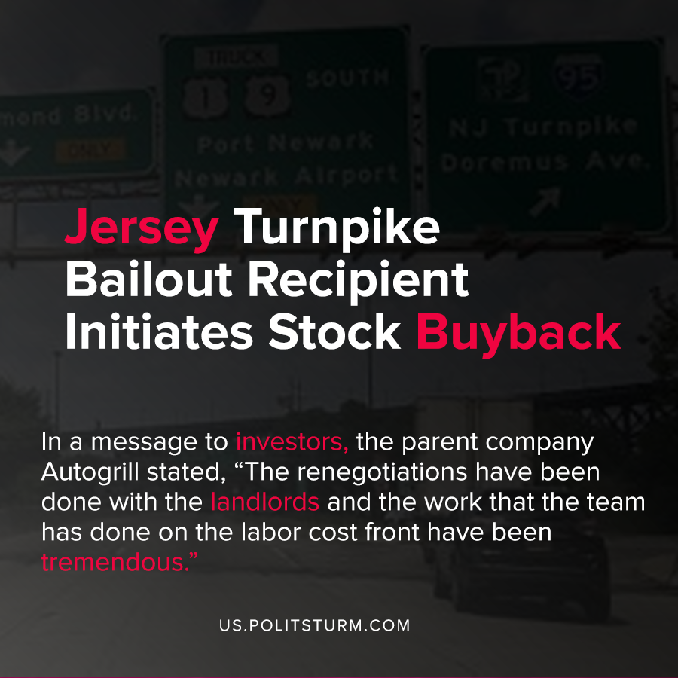

Original article
2020-10-20
1 min read

A recent research briefing by UNITE HERE, the New Jersey Turnpike Authority (NJTA) agreed to fund $40 million in construction costs that were the responsibility of HMSHost. HMSHost is a turnpike and airport food service company that had agreed to a $150 million investment in the New Jersey Turnpike and Garden State Parkway.
Key findings from the research include that the net assets of the billionaire owners of the company were $13.8 billion as of the end of 2019, and that the company stated it was unable to continue paying its contractors while increasing its cash balance since the beginning of 2020.
In addition, the company engaged in share buybacks and “between March 23th, 2020 and March 27th, 2020 it bought back, on the regulated market (MTA) managed by Borsa Italiana, 1,532,873 (of it’s) own shares at an average price of € 3.9996 per share for a total amount of € 2,814,472.98.
Simultaneously, the company was laying off thousands of its workers in order to reduce labor costs. In a message to investors, the parent company Autogrill stated, “The renegotiations have been done with the landlords and the work that the team has done on the labor cost front have been tremendous.”
We see once again the state serving the interests of the capitalist class at the expense of the workers. While the corporate executives enrich themselves through stock buybacks, workers are laid off and lose their livelihoods.
The New Jersey Transit Authority has raised its tolls during the most recent capitalist crisis, while in its stated objective it seeks to “Maximize the total rate of return on invested funds” for the investors.
The entire capitalist system is dedicated towards the maximization of profits for the oligarchs, at the expense of the mass of working people.
Source: 1 , 2 , 3 , 4

Original article

