Jeff Bezos Fortune Eclipses $200 Billion
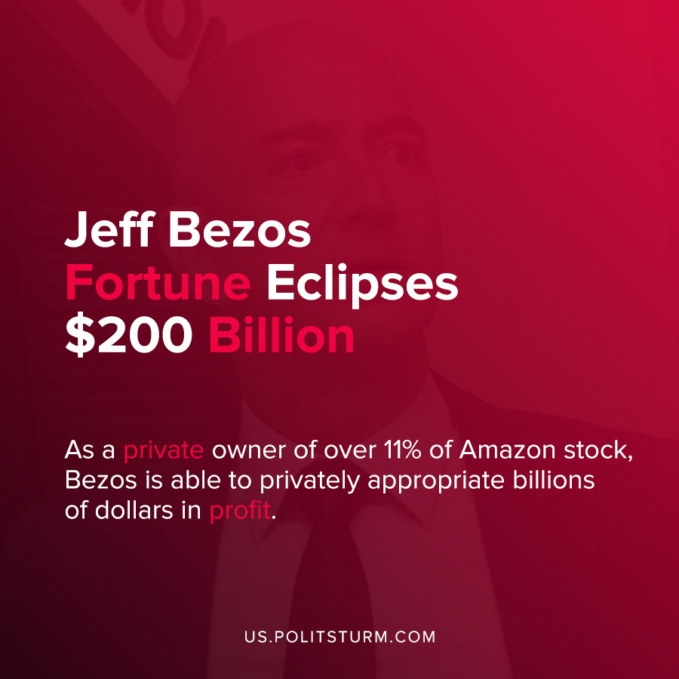

Original article
2020-08-29
1 min read

Amazon CEO Jeff Bezos recently became the first person in history to have a net worth over $200 billion, according to a recent publication by Forbes. Bezos’ net worth has dramatically increased as the stock price of Amazon has continued to surge during the pandemic and he holds an 11% stake in the company.
In the most recent quarterly report to shareholders, Bezos credited employees for their contributions.
“This was another highly unusual quarter, and I couldn’t be more proud of and grateful to our employees around the globe”, said Bezos.
As a private owner of over 11% of Amazon stock, Bezos is able to privately appropriate billions of dollars in profit. These profits are the unpaid wages of the global working class which are siphoned off to wealthy individuals such as Bezos, or to institutional owners.
As long as the ownership of the means of production is private, the owners will be able to amass massive private fortunes off the labor of the working class. Alongside the massive increase in the wealth of a small minority of private owners at the expense of the mass of workers.
Only the struggle for socialism will save the working class from the constant deterioration of life and open the way to a better future – without oligarchs, exploitation and poverty.
Source: 1, 2

Original article

