Jean Jaures on Wars
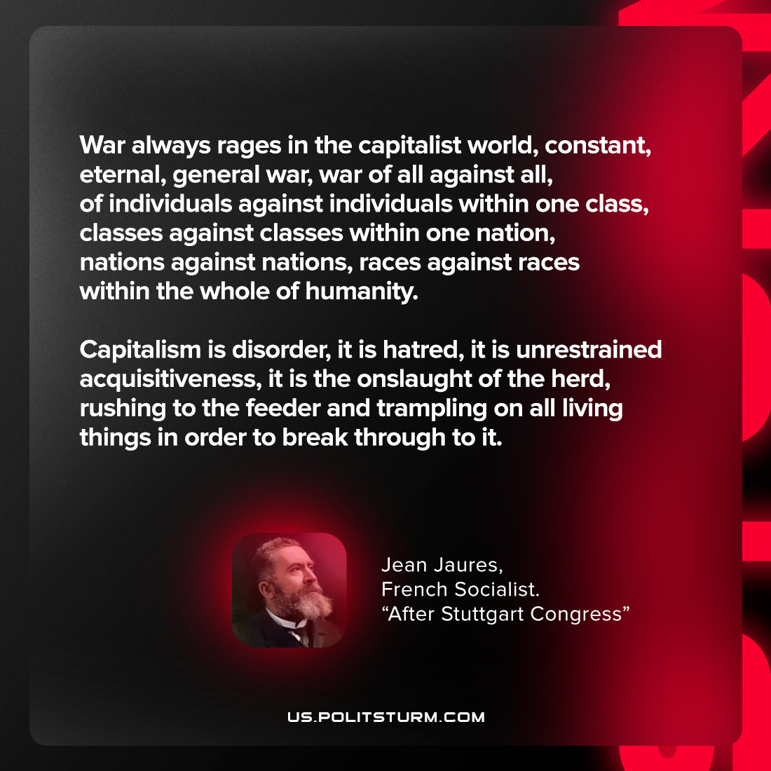

Original article
2022-03-02

War always rages in the capitalist world, constant, eternal, general war, war of all against all, of individuals against individuals within one class, classes against classes within one nation, nations against nations, races against races within the whole of humanity.
Capitalism is disorder, it is hatred, it is unrestrained acquisitiveness, it is the onslaught of the herd, rushing to the feeder and trampling on all living things in order to break through to it.

Original article

