JBS Hack Leads to Mass Stoppages for Meat Production
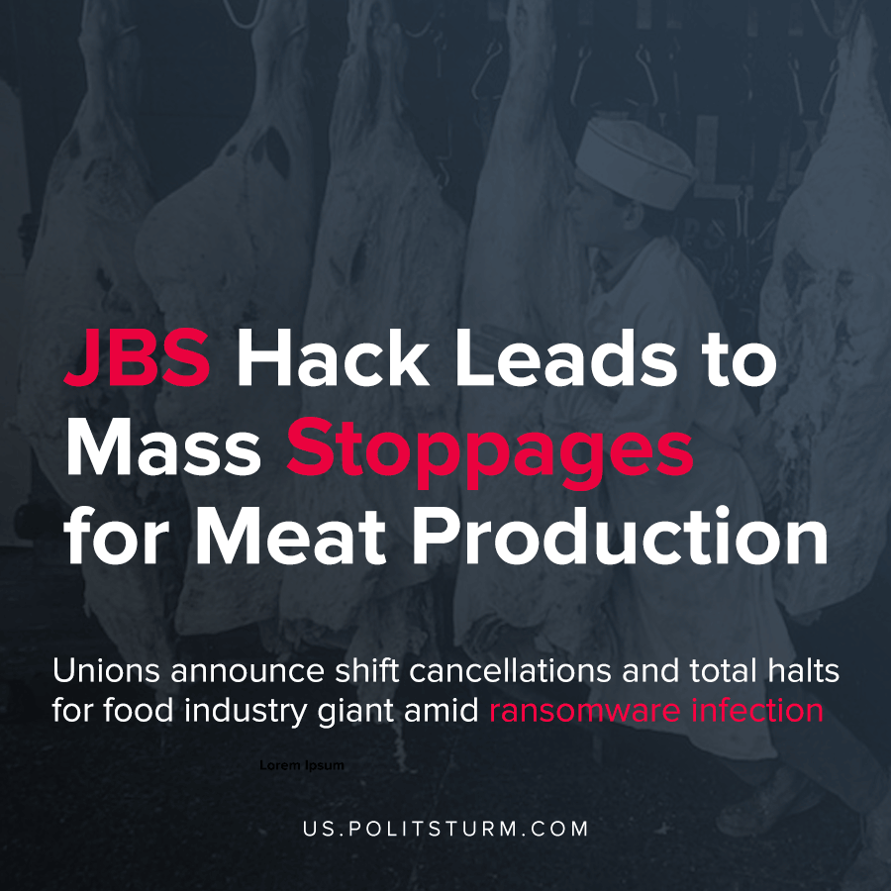

Original article
2021-06-02
1 min read

JBS Foods, top world food supplier, suffered a ransomware cyberattack Sunday, May 30th, which resulted in the crashing of several of its servers in North America and Australia.
Immediately, the company ordered all beef and lamb slaughtering halted for Australia. Shifts for processing in U.S. and Canadian factories were postponed. Delays to customers and suppliers had been warned, but now seem unavoidable as all JBS USA beef facilities have been closed.
Now, after limited stoppages announced by UFCW Local 7 in Colorado and other UFCW locals for Monday and Tuesday, extensive stoppages have been ordered by JBS in Pennsylvania, Tennessee, Michigan, Texas, Arizona, Utah, Wisconsin and Nebraska.
Spokesman Scott Payne for UFCW Canada Local 401 spoke to reporters about the work stoppage at the Brooks, Alberta JBS facility:
“There are no unionized workers there… That means effectively the plant’s operations have shut for the day.”
Operations at the company’s packaging facility in Belleville, Ontario, however, were not stopped, and shifts in the Brooks facility were renewed for Tuesday afternoon.
JBS’s Brooks facility makes up over 25% of meat production for the entire country of Canada, and the company owns 22% of the U.S meat industry. Market overseers warn that an extended failure of production by the Brazilian-based global food monopoly JBS and its subsidiaries could lead to disastrous holdups in the supply chain, and promise further percentage increases in beef prices.
Recently, JBS and the other three masters of the industry Cargill, National Beef and Tyson Food, who combined control over 85% of the US market, have been investigated by the U.S. government for price fixing – JBS has been ordered to pay over 57 million dollars in damages for meat price-fixing just this year.
This latest production fault, which plays to the advantage of the industry’s controlling capitalists, is expected to worsen already high prices for foodstuffs. Once again, workers are left hanging off the current economic precipice by the callous exigencies of the capitalist mode of production.
Source 1, 2, 3

Original article

